EDMODO: Edmodo is a free instructional platform. JCTC used the platform to create classes with a combination of videos, diagrams and subject matter content, practice worksheets, quizzes, and assignments. One instructor, Don Poe, uses this platform.
Subjects topics are arranged in folders which serve as a library of information on the topic. Subject list and folder topics within follow on attached pages. Class folders are attached.
Pros: No direct costs to program, easy for both student and instructor to use. Message system for all enrolled students making it easy for two way messaging to occur with alerts on the students’ phones. This allowed instructor to promote Zoom classes for the same subject.
Cons: DOES NOT TRACK STUDENT TIME. Use fell off with COVID 19 as many of these students seem to have stopped out (Initially used with students who were also face to face). Sometimes page doesn’t easily load. The video links must be monitored by the instructor because occasionally video locations disappear or change.
Enrollment: Students must have a class code to sign up. Information sheet follows.
Sample report from February (before COVID 19). 59 students are currently enrolled.
GED Math 6 enrolled
GED Math Spanish 6 enrolled
GED Science/ SS 25 enrolled
GED Sci/ SS Span 12 enrolled
Total Enrolled 49 enrolled

Student watched all the Edmodo Science videos and passed her GED Science test will not being able to attend GED Classes.

Student participates in class(face to face) irregularly and watched the Edmodo videos and passed his Social Studies GED Test, prepping for Science. Commented on enjoying the Edmodo program, he can watch on breaks at work.

Student participates in class irregularly and watched the Edmodo videos and passed his Social Studies GED Test. Commented saying the Edmodo program helped him pass., he can watch on breaks at work and at home. Passed Science GED Test

Student cannot make classes but was introduced to Edmodo and thought it was going to be beneficial for him. Passed GED Science

Invitation/ Instructions for enrollment for the students. Each class has a different code
https://api.edmodo.com/groups/29792619.pdf?pdf_format=intl
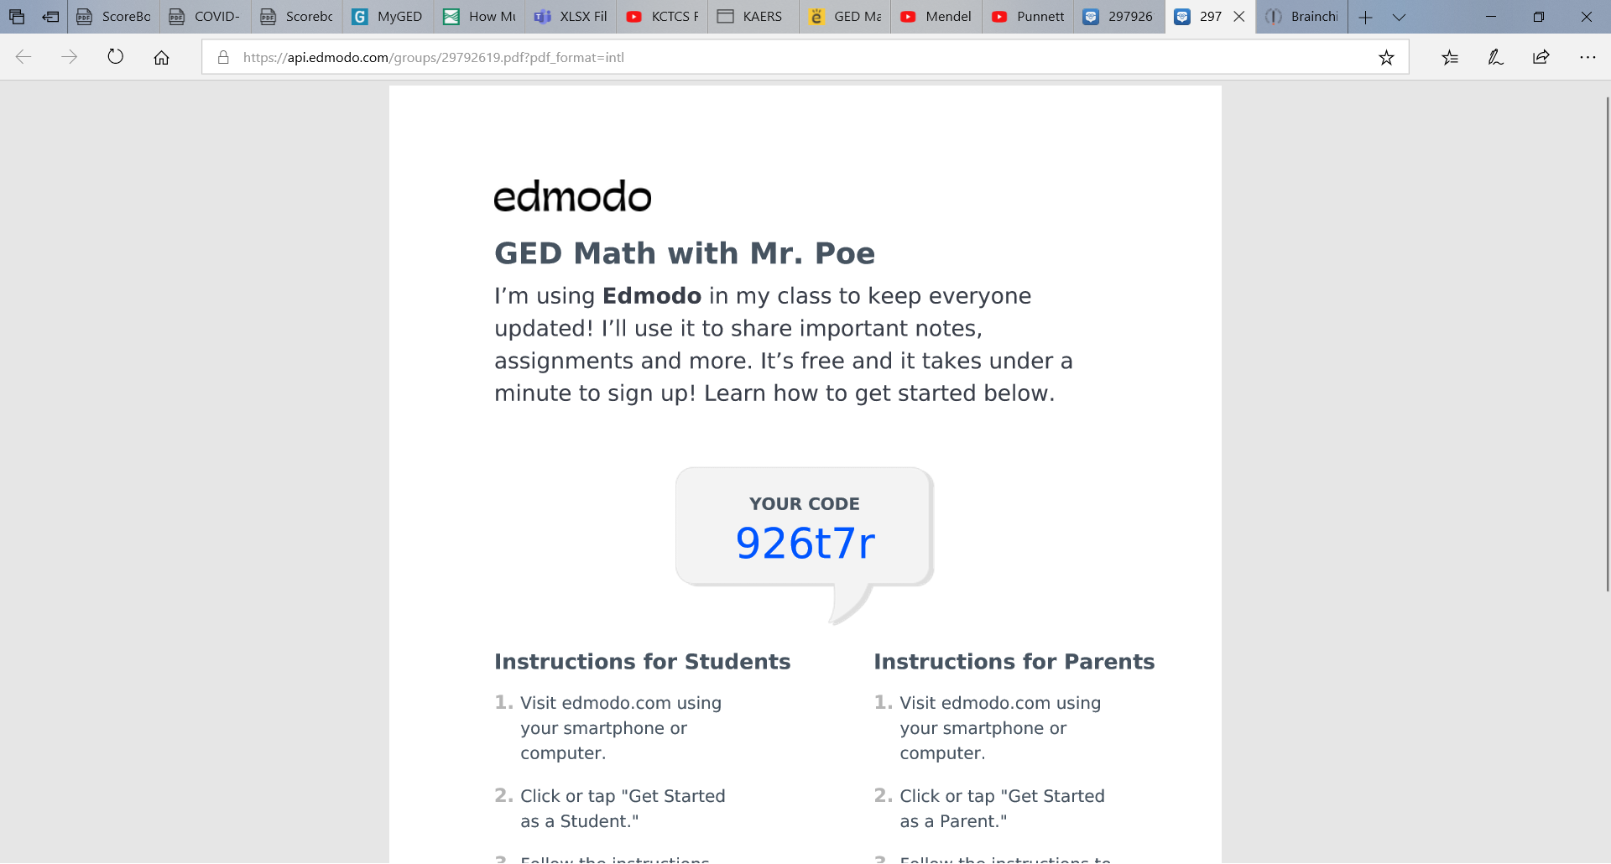

These are the classes set up in Edmodo

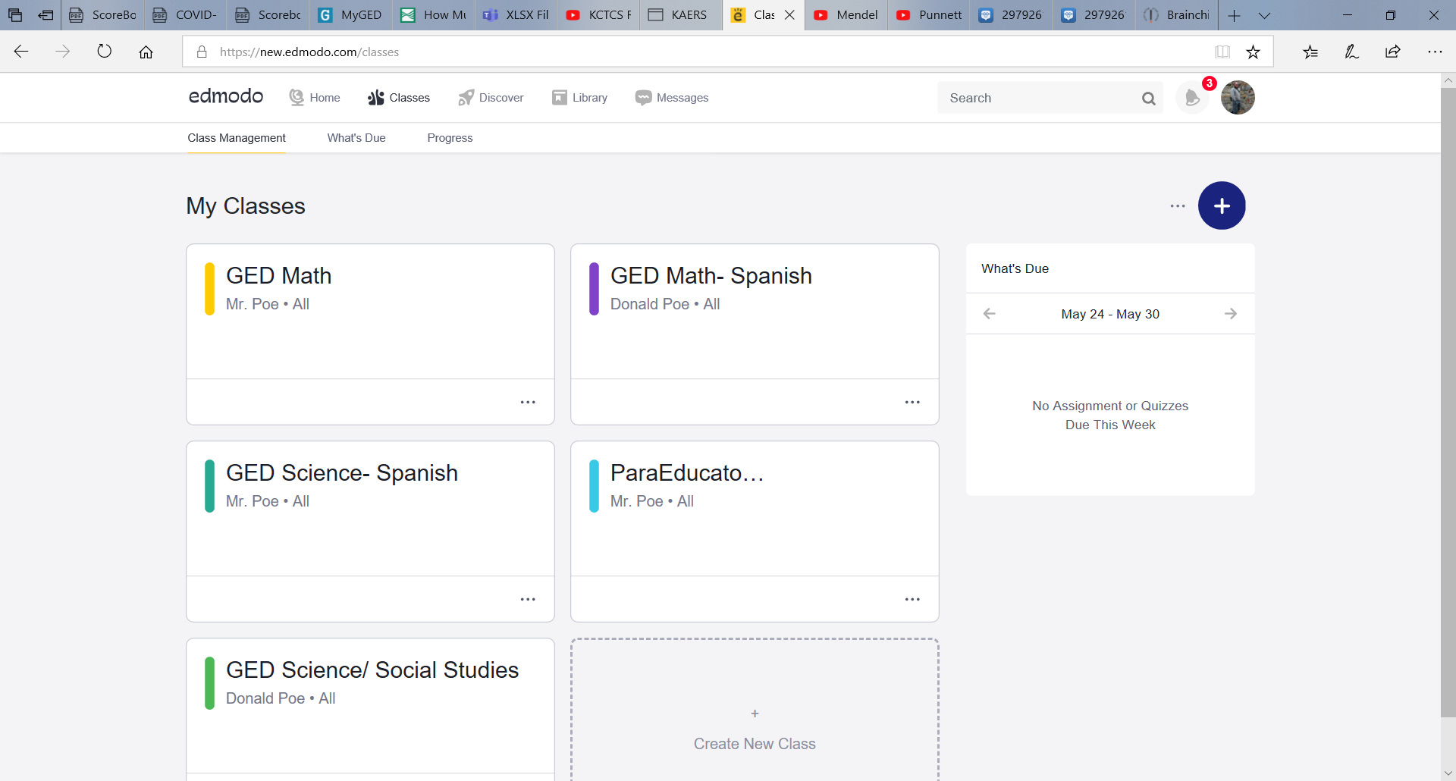

A Folders section is created for each class, this is where videos and worksheets are stored.

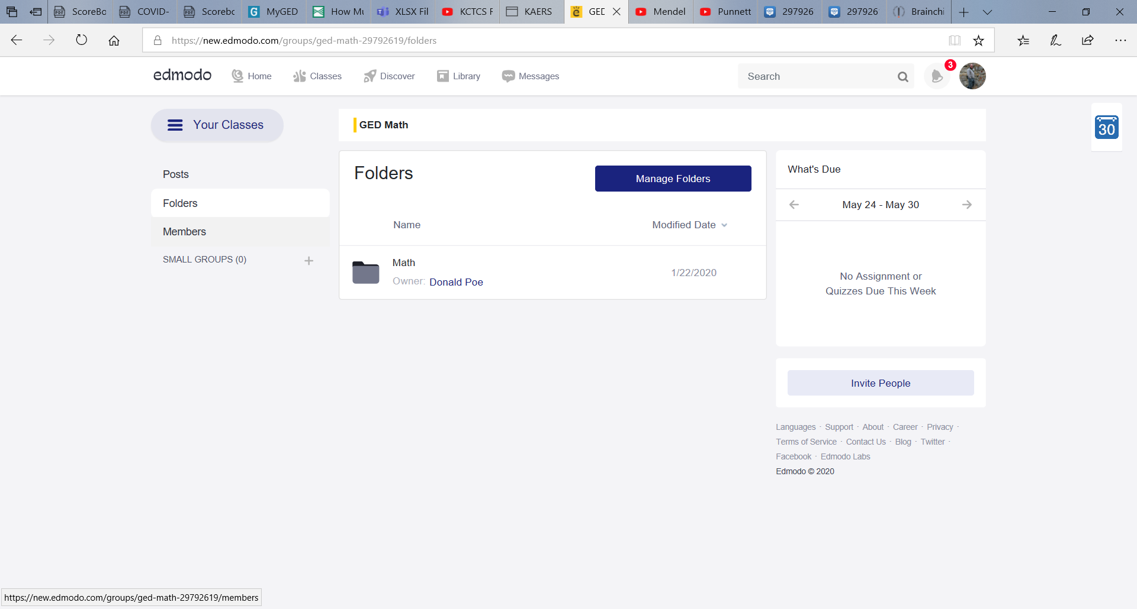
For the Math Class the folders are setup like ScoreBoost. The ScoreBoost Math packet titles are used as folder names. A general folder titled GED Materials was also created which has links to the GED Calculator Reference sheet and Formula Sheet as well as other material.
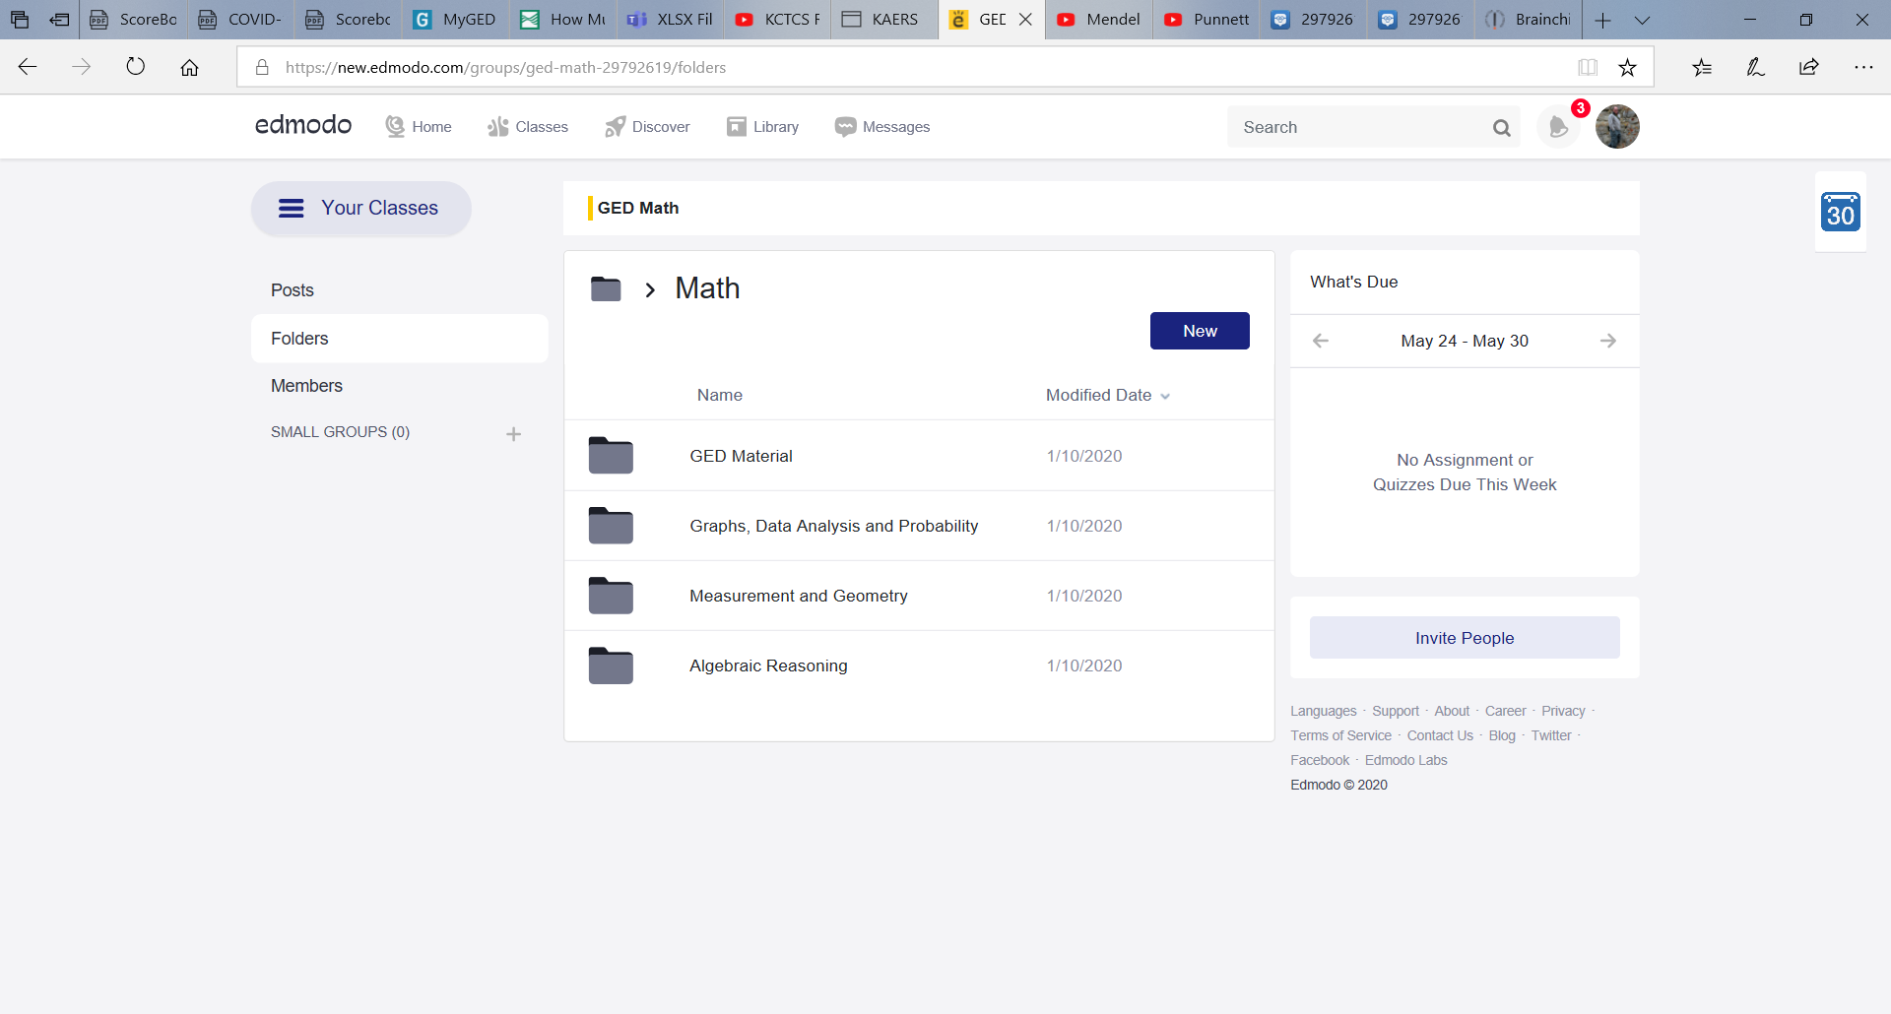

Inside each folder is the Unit # that matches the ScoreBoost Contents page.
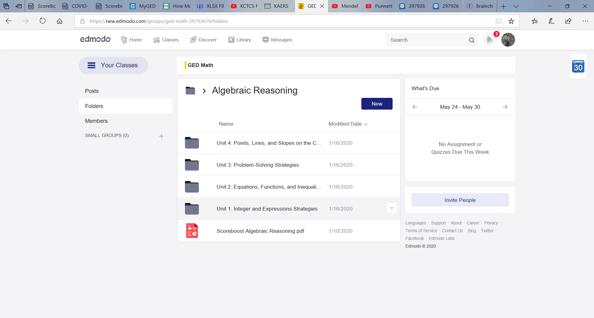

Each Unit Folder is broken down by the Strategies. Then inside each strategy will be the videos and worksheets to help students understand. This allows the students to follow along with their primary study material that we use, ScoreBoost. It can be modified for any study material source or the instructors desired material.
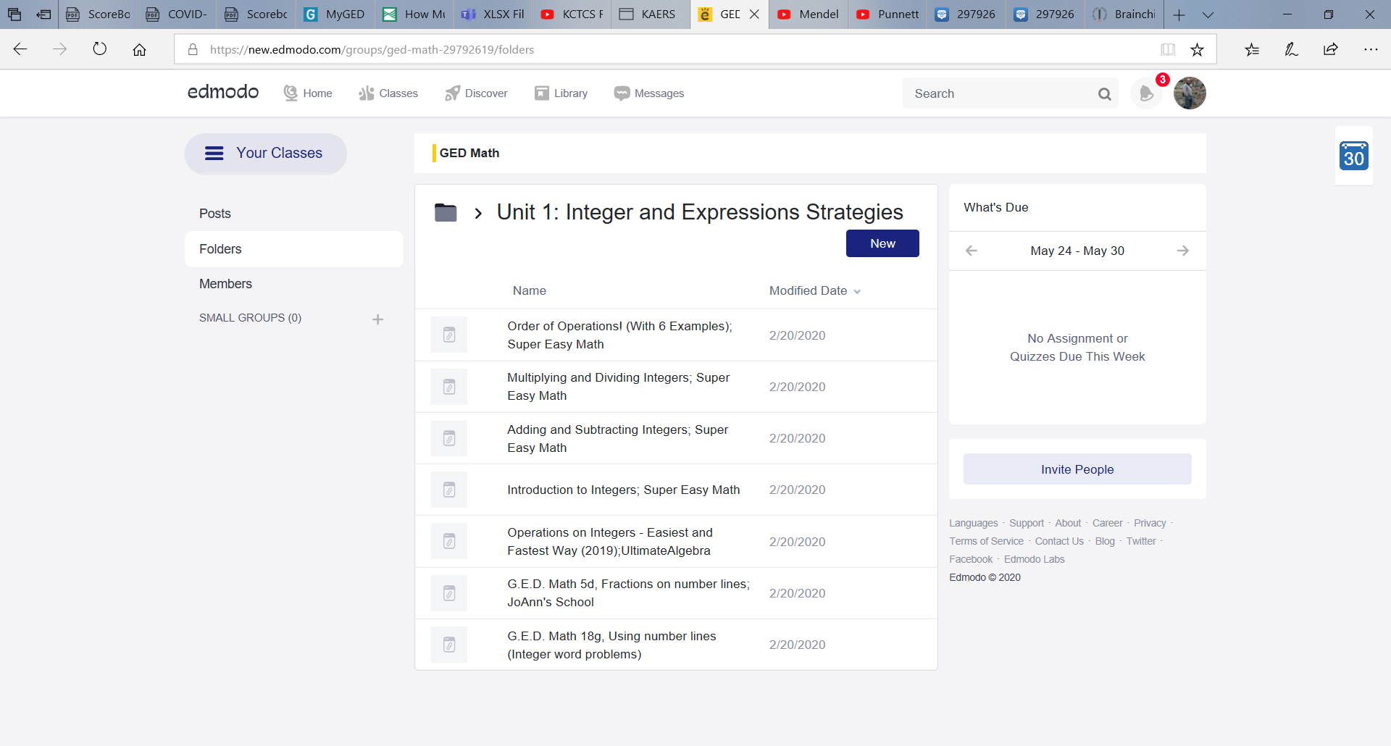
Below is the Science folder as it is setup by categories covered in the GED Test, some of which do not fall into the ScoreBoost material. The Science class folders are setup by topics that are important for passing the GED Test but may not be included in the study material we use. All topics listed have related questions on the GED Science/ Social Studies Test.
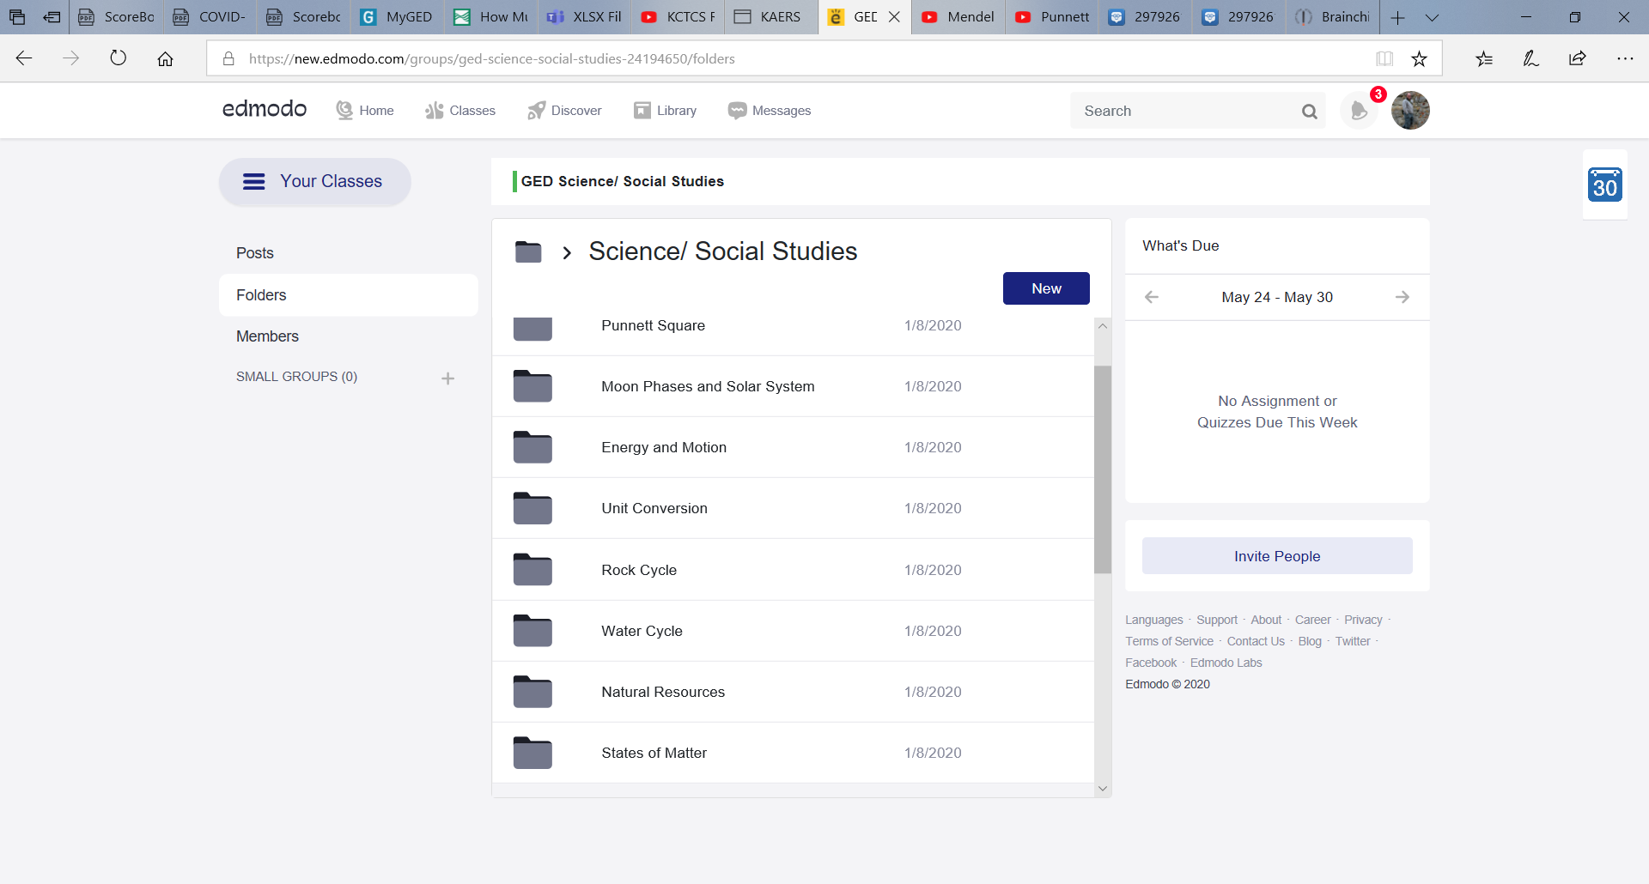

Inside the folder are the selected videos and worksheets to assist students in learning each particular topic.

