12M Math Review
Part 1 (No Calculator)
- Fill in the blank to make the number sentence true.
$$4×____=\frac{4}{5}$$

- Which answers are equal to the area of the rectangle? 7 ¾ feet
- $7\frac{3}{4} feet+5 feet$
- $39\frac{1}{2} square feet$ 5 feet
- $7\frac{3}{4} feet ×5 feet$
- $38\frac{3}{4} square feet$

- A rectangle has a width of $\frac{3}{4}$ meter and an area of $\frac{15}{28}$ meter. What is the length of the rectangle?
- $\frac{45}{112}$
- $\frac{5}{7}$
- $1\frac{2}{3}$
- $2\frac{2}{3}$

- Divide $1,456÷28$
- 52
- 48
- 51
- 49

- You make $10 an hour for 40 hours of work. Then $13 an hour for hours worked above 40 hours. What would be the equation you would use to find the number of hours, h, that you worked above 40 if you made $595 for the week?
- 40 - (10h+13) = 595
- 40(13) + 10h = 595
- 13h+10h + 40 = 595
- 10(40) + 13h = 595

- Simplify the expression $(16+9)÷5$
- $\frac{16+9}{5}$
- $16÷5+9÷5$
- 5
- 25

- Describe how to get to points A and B from the origin.
A: Move right _____units and up _____ units B: Move left _____ units and down _____ units
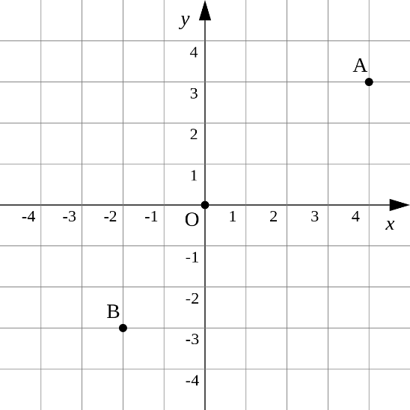

- Select all equivalent expressions to the following expression. $5(y-4)$
- 5y-4
- 5(y) – 5(4)
- 5y-4y
- 5y-20
- -20y

- You are serving sub sandwiches for a party. You have 15 people coming and are going to serve them ¼ sub to each person. How many sub sandwiches are you going to serve?
- 60
- $3\frac{3}{4}$
- $5$
- 3

- $7,056×8=?$
- 56,448
- 56,442
- 56,048
- 57,248

- Which represents the statement “42 is 6 times as much as 7”?
- $6+7=42$
- $42×6=7$
- $6×7=42$

- Which question is a statistical question?
A) How far does Sarah live from her school?
B) How many blocks is Chris's home from school?
C) How far is NLMS from the library?
D) How far do the teachers at NLMS live from the school?

- Which dimensions cannot be used to form a right rectangular prism with a volume of 36 cubic inches?
- Area of base = 6 square inches Height = 6 inches
- Area of base = 9 square inches Height = 4 inches
- Area of base = 4 square inches Height = 8 inches
- Area of base = 12 square inches Height = 3 inches

- Write the inequality that correctly compares the two decimals that are represented by the shaded parts.
- $0.11>0.35$
- $0.011>0.035$
- $0.11<0.35$
- $0.011<0.035$
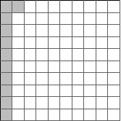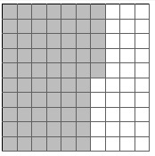

- What is 478,641 rounded to the nearest hundred?
- 478,700
- 478,600
- 500,000
- 478,640

- Rick ate 2 pieces of pizza; Joe ate 4 times as many as Rick. Create an equation to find how many pieces Joe ate.
( ) ( ) ( ) = [ ]
Pick from the following to create the equation….
0 1 2 3 4
5 6 7 8 9
+ $-$ $×$ $÷$ .

- You’ve got ¾ gallon of milk left. If you wanted to divide up the milk evenly between 5 people, how much would you pour in each glass?
- $\frac{3}{20}$
- $\frac{1}{5}$
- $\frac{3}{5}$
- $\frac{4}{5}$

- You need to cut a board that is 10 feet long into 3 equal sections. How long will each board be?
- 3 feet 3 inches
- 3 feet 4 inches
- $3\frac{3}{10}$ feet
- 3.3 feet

- What is equivalent to this expression? $7(3x+5)$
- 21x + 5
- 56x
- 21x + 35
- 7+ 15x

- What shape is represented by the net?
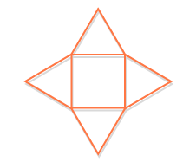 A B 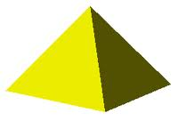

C 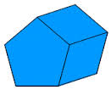 D 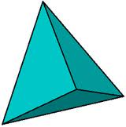

- The line plot shows the lengths of Nails. What is the difference between the longest and the shortest nail?
x
x
x x
x x x
x x x
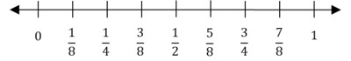
- $\frac{3}{4}$
- $\frac{5}{8}$
- $\frac{1}{2}$
- $\frac{3}{8}$

- Which shaded figure shows the sum of $\frac{2}{8}+\frac{3}{8}$ ?

A B

Two shapes shown here A: parallelogram B: rectangle. Mark all that apply.
- both have 2 pairs of opposite sides that are the same length
- both have 2 pairs of parallel sides
- both have right angles
- both are quadrilaterals
- both have equal perimeters

- How many centimeters (cm) is 6 meters (m)?
- 6000
- 600
- 60
- 0.6

- ∠ABD measures 110° Find the measure of ∠ABC if the measure of ∠CBD is 37°
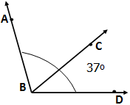
- $147°$
- $73°$
- $53°$
- $127°$

- Simplify. $4^{2}×2^{3}$
- $8⁵$
- 8⁶
- 128
- 48

- What is the measure of the angle?
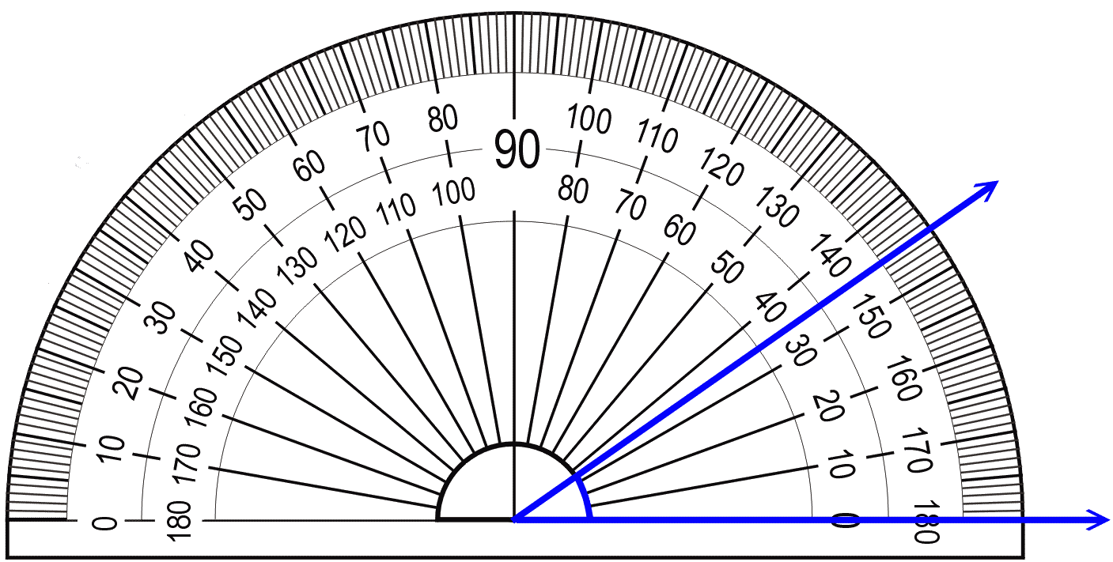
- $35°$
- $145°$
- $180°$
- $45°$

- Write the number thirty-five thousandths.
- 35,000
- 3,500
- 0.0035
- 0.035

- What is the measure of an angle that turns through x one-degree angles?

- If you buy one video game for $45.96 and another for $34.99 what will be your total?
- $79.95
- $80.95
- $79.05
- $80.05

- Which point lies on 2 lines? Mark all that apply. A
- Point A B
- Point B
- Point C
C

- The table shows the results from a survey in which people were asked what their favorite ice cream flavor was. Choose the correct histogram that reflects the data in the table.

Flavor | Frequency
Chocolate | 17
Vanilla | 14
Strawberry | 10
Swirl | 3

A B C D

- The distance that a vehicle travels is given below, where r is the rate of speed, t is the time, and d is the distance traveled.
$$rt=d$$
If the vehicle travels 196.5 miles in 3 hours, what is the vehicle’s rate of speed (mph)?
- 55.5
- 56
- 589.5
- 65.5

- In which number does 3 have a value that is ten times the value of the 3 in the number 300?
- 301,256
- 247,423
- 563,241
- 465,734

Part 2 (Calculator)
- If you pay $18 for 6 bottles of tea, what is the unit rate for the bottles?
- $108
- $0.33
- $6
- $3

- Which decimal is 67.858 rounded to the nearest hundredth?
- 67.86
- 67.85
- 67.859
- 67.9

- What is the solution to the equation?
$4d+40=100$
- 35
- 15
- -15
- 25

- Which sequence follows the pattern add 6, subtract 2?
- 6, 2, 6, 2, 6, 2, …
- 2, 8, 6, 12, 10, 16, 14, …
- 0, 6, 8, 14, 16, 22, 24, …
- 6, 8, 10, 12, 14, …

- A sponsor at a walk-a-thon has committed to give you a flat fee of $5 plus $2 for every mile that you walk.
Part 1) Let m represent the number of miles that you walk. Create an expression that can be used to find the number of miles that you walk.
- 5m + 2
- 7m
- 5m + 2m
- 2m + 5

Part 2) You raised $35 for the walk-a-thon. How many miles did you walk?
- 15
- 5
- 6.6
- 10

- You need at least $10 to buy a gift for the birthday party. Create a number line that represents this inequality.

Answer Key
Part 1
- $\frac{1}{5}$
- C and D
- B
- A
- D
- C
- A: Move right 4 units and up 3 units B: Move left 2 units and down 3 units
- B and D
- B
- A
- C
- D
- C
- C
- B
- $\left( 4 \right)\left( × \right)\left( 2 \right)=[ 8 ]$
- A
- B
- C
- B
- D

- A, B, and D
- B
- B
- C
- A
- D
- x degrees
- B
- C
- C
- D
- C
- D
- A
- B
- B
- Part 1) D Part 2) A

10

