AppointmentPlus Enterprise Scheduling Software

|  |
| --- |
| Comprehensive  User Guide |



Authored by the PLC Call Center Team

Adrianna Aviles Nina Mounce

Janie Patterson Pat Boyd-Shaw

Justin Nagler Susan Carrell

Michelle Wright Susan-Ward Repishti

January 2020

JCPS Skills U 



**Introduction**

AppointmentPlus is a well-respected technology platform designed to create a customer tracking data base, appointments, scheduling, no-show tracking, security, and reports. This User Guide will assist you to use AppointmentPlus to meet the needs of our adult education programs. The program is simple to use once you begin working with it. Generally, the Call Center, Testing Center, Navigators and Instructional Assistants will be entering data. However, the information on each student, especially the “notes” section on each student’s running record, is very helpful to review.

The Program Administrator will be responsible to edit the information to meet our needs. All other staff will use the program but should not attempt to make changes; instead, send any suggestion or request to the manager. All staff will have a username and password to access the program. Generally, staff are identified as “users” and will not have access to all tabs.

We will begin by opening AP+. Go to https://www.appointmentplus.com. Enter your username and password.

|  |
| --- |
| **Administrator: _____________________________________** |

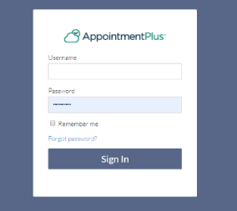

When you open AppointmentPlus (AP+) and log in, you will first see the nine tabs shown below:

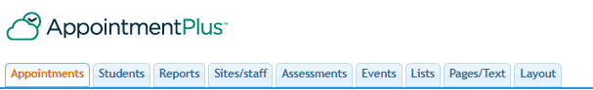

Each tab is outlined in the User Guide for you. Basically, information is entered for “**Appointments**” and “**Students**”. The information in “**Reports**” is very useful to track data on a variety of interests, i.e., “No Shows”. The remaining six tabs may provide useful information and are **maintained by the administrator.**

Click on “**Login**” at the top right of the screen. Enter your username, password and click “Sign In”. Your home page screen should be as shown below. Note that the current date will be highlighted.

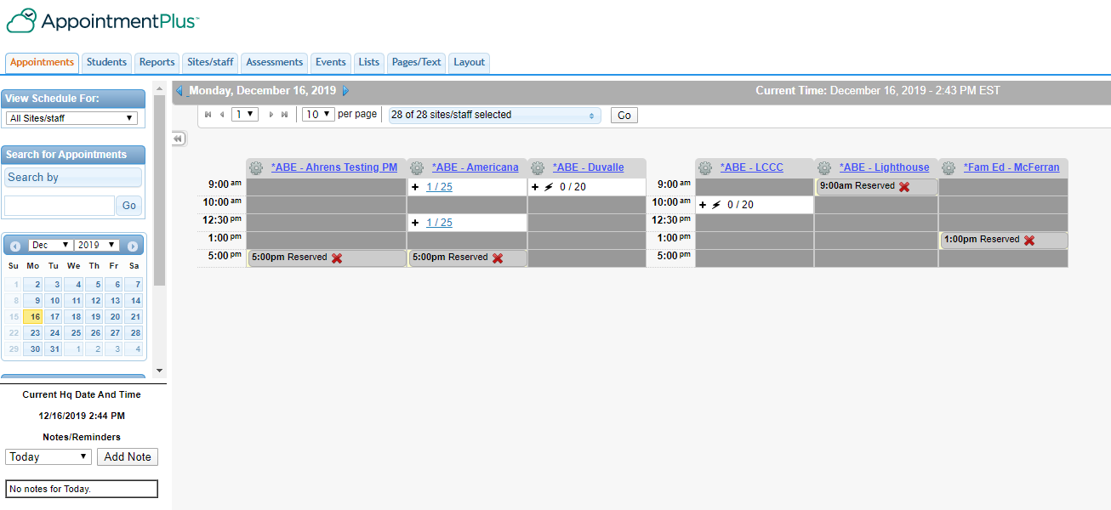

1. **Appointments**

We will begin with “Appointments”. Click on the “**Appointments**” and the dropdown arrow head next to “**All Sites/staff**”. Here you will see a list of all sites and programs in the column and the beginning of the calendar is used to schedule appointments.

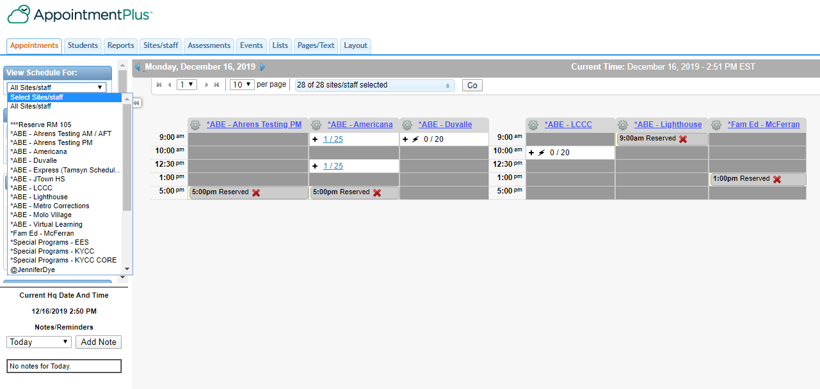

The following will have instructions for two uses of Appointments: (A) to make appointments for new students and (B) to make an appointment for a student already entered in AP+.

**New Students:**

1. To set an appointment for a new student not in AP+, follow the instructions for entering a new student shown in II. Students**.**
2. Once the enrollment is complete, select the “**Make Appointment**” and click on the site selected by the student. The example below is DuValle:

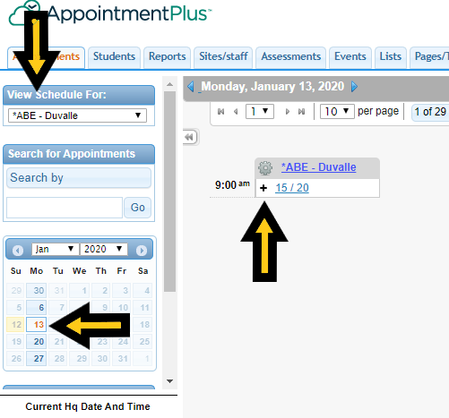

The screen will show the next available date and time. If this is what you want, click on the (+) sign in the box and the student will be added to the list. The list shows that 15 students are already registered, with a limit of 20.

If the list is full, or you want a different date, simply click on the date chosen. If a site is closed, the box will be grayed out and have a red X to indicate the site is not open (as shown on page 3).

When you click on the (+) sign, the student’s information will automatically transfer to an appointment. Click next at the bottom.

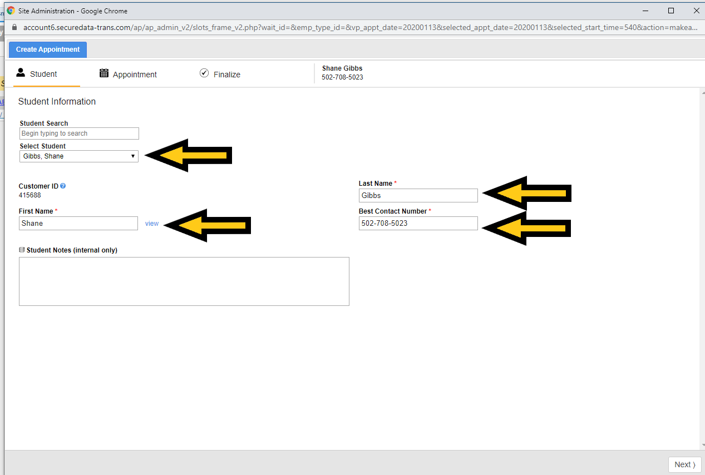

Under “**Assessment**”, click on the dropdown arrow menu to select which test you are requesting for the student. Click “Next”.

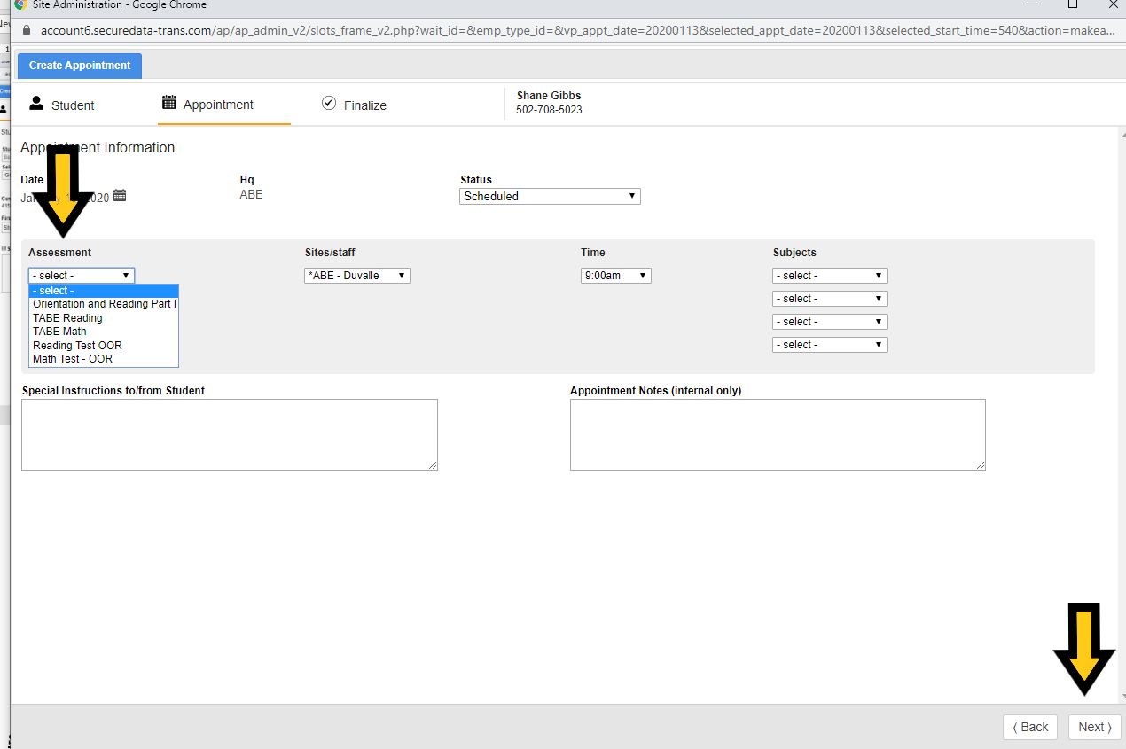

The “Finalize Appointment” screen will display the selected appointment. If the student would like a phone text reminder an hour before the test, enter the number in the box “mobile phone”. If they choose not to have a text, click on the arrow above the flag and the reminder will clear. Click on “Finalize Appointment”.

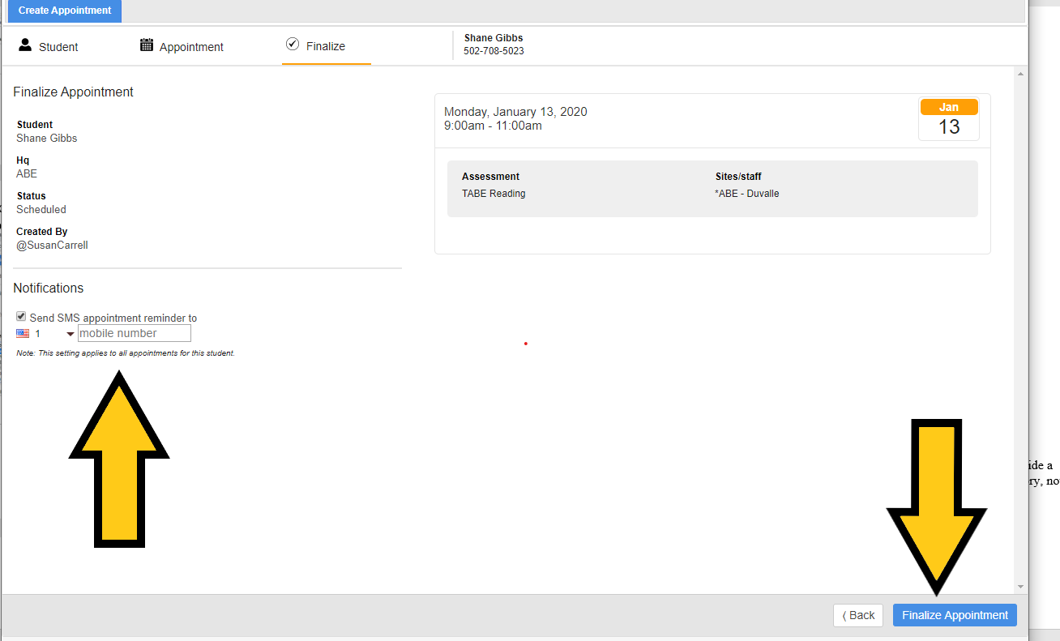

The final screen will allow you to edit any changes. At the top, you will see “Profile”. Click on it to bring up the enrollment, scroll down to the

“Add Notes” box and add in any important information. Click on “Update” to save.

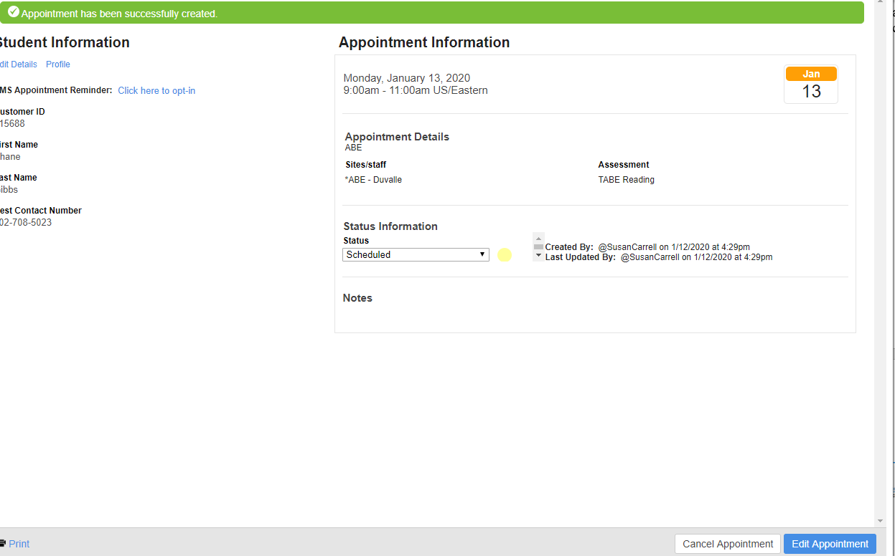

**Checking for Site Appointments:**

Click on the list of students for the site. Your student’s name will appear. If you elect to delete this appointment, select “**View Appointment**”, and you can cancel it.

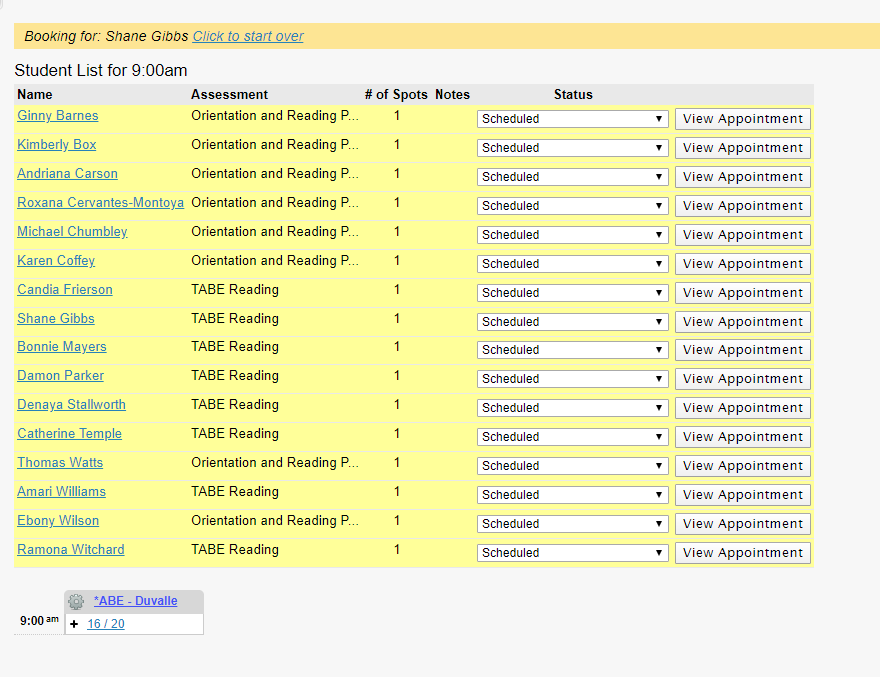

When you click on the dropdown arrow under “**Status**”, you are given a menu showing the student’s status.

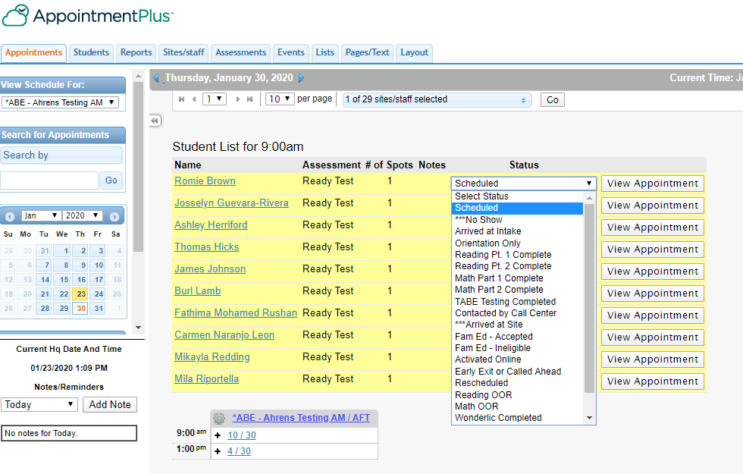

1. **Students**

**Student Tab Overview**

The “**Students”** tab is used to add, view, edit, and delete student profiles. It will provide and maintain a complete database of our students including contact information, appointment history, notes, and other information.

**Searching for a Student**

To search for a student, click on the “**Search Students**” tab shown below.

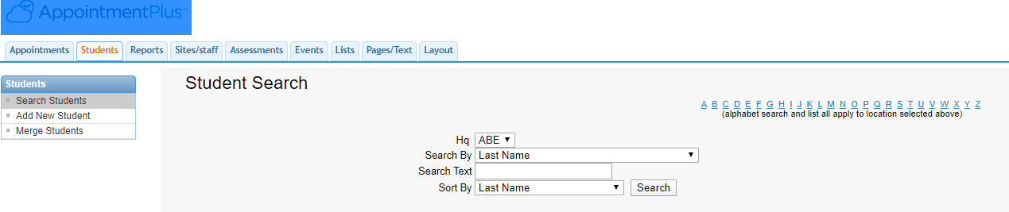

When you do that, the “**Student Search**” page is displayed. From this page, a search can be performed a number of ways:

* **Alphabetically**: Click on a letter of the alphabet (shown above in blue), all students whose last name begins with that letter will be displayed.
* **Search By fields**: Search for students by a specific field. Click on the upside-down triangle at the end of the **Last Name** box shown above to display the dropdown menu. Then select a field to do your search. For example, if you select Last Name to do your search and the name last name is Smith, all students with this last name will be listed.
* Before adding a student, ask the student if he or she has been in adult education before. Even when they say “No.”, ask for the last name, then first name. If they are in the system, verify the address and phone number. Then use this profile to schedule a test. You would be surprised how many will say no when they have in fact been enrolled. **This ‘checking’ helps to prevent the duplication of students.**

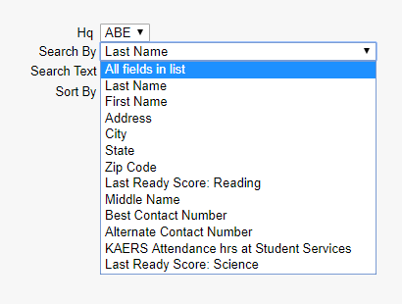

**Adding a New Student**

Click on the “**Add New Student”** link in the left navigation menu.

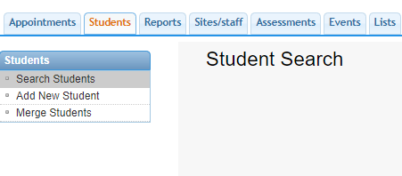

The student’s information is entered into the applicable fields (shown below) to create a profile without first making an appointment. Make sure all information entered is accurate. Double check the spelling of names and dates. Once the information is entered, click on the “Add” button to save it.

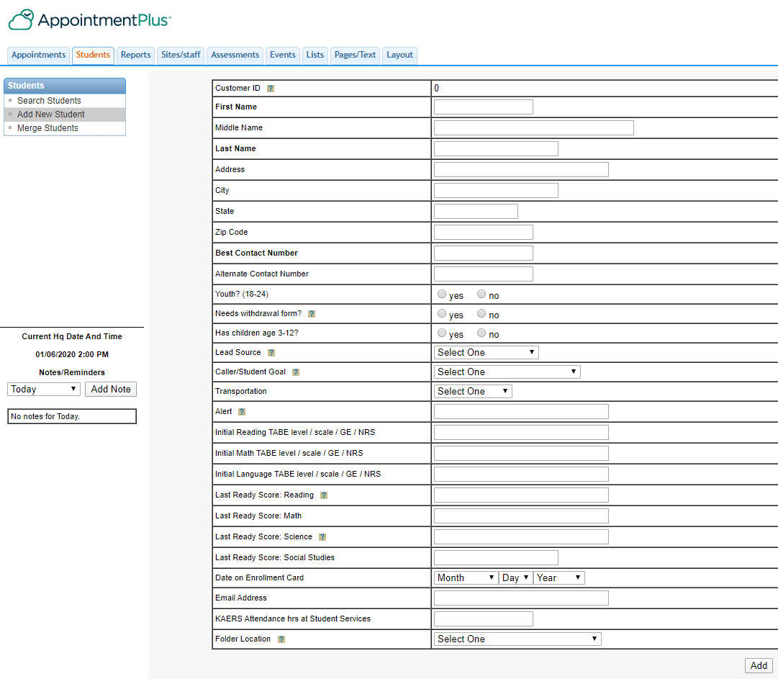

When a student is referred from a specific program, we place a code behind the student’s last name as follows: Probation and Parole is (P&P); GEDPlus+ is (GED+); and Kentucky Career Center is (KCC). Additional programs will be added as we receive referrals.

**Student Information Page**

The box below shows the options for this page.

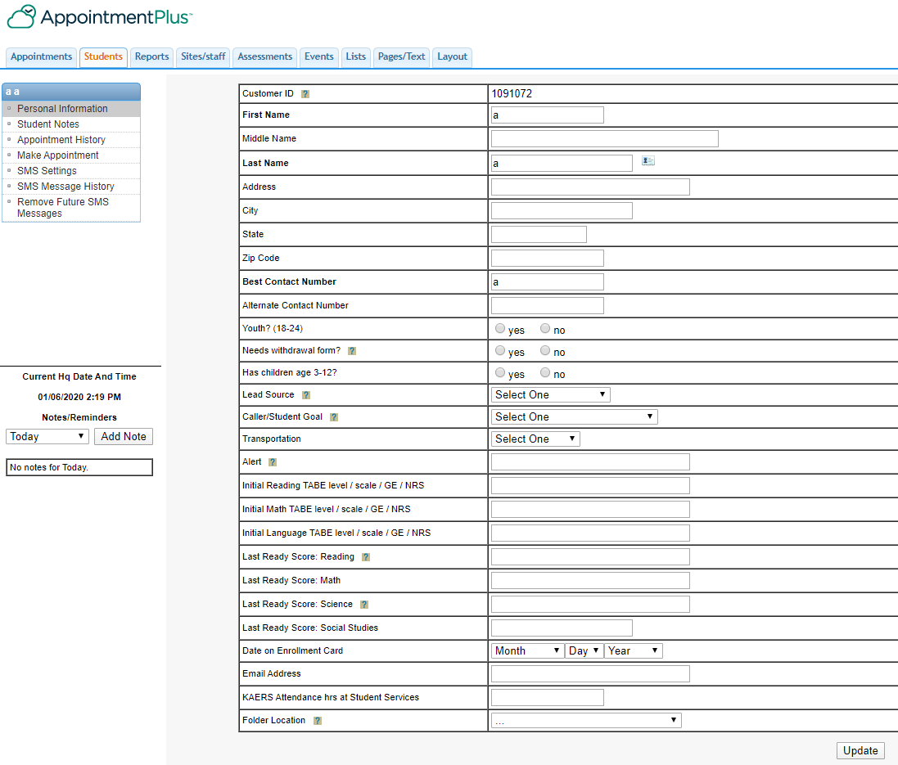

Click on the “**Student Notes”** option to add any information about the student that should be saved or shared. Student notes should include calls made to the student, emails sent, student discipline made, etc. After you have added the note, click on the “**Add Note”** box to save the information. The date will automatically appear on your note. We must be careful of the information we record. DO NOT ENTER PERSONAL INFORMATION. For instance,

you might enter “has had health issues” as opposed to “has had cancer”.

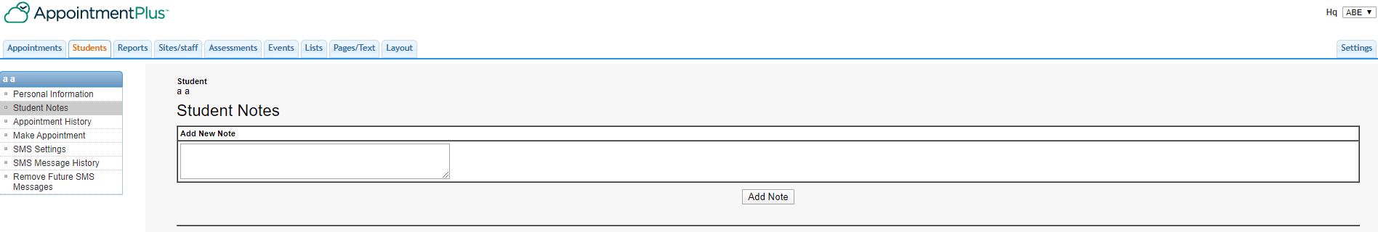

Click on **Appointment History** to see the student’s appointment history. If a student shows at your site who does not remember when they tested, you can look in their history to see all their appointments and if they completed testing.

The student’s name will be shown above “**Personal Information”**.

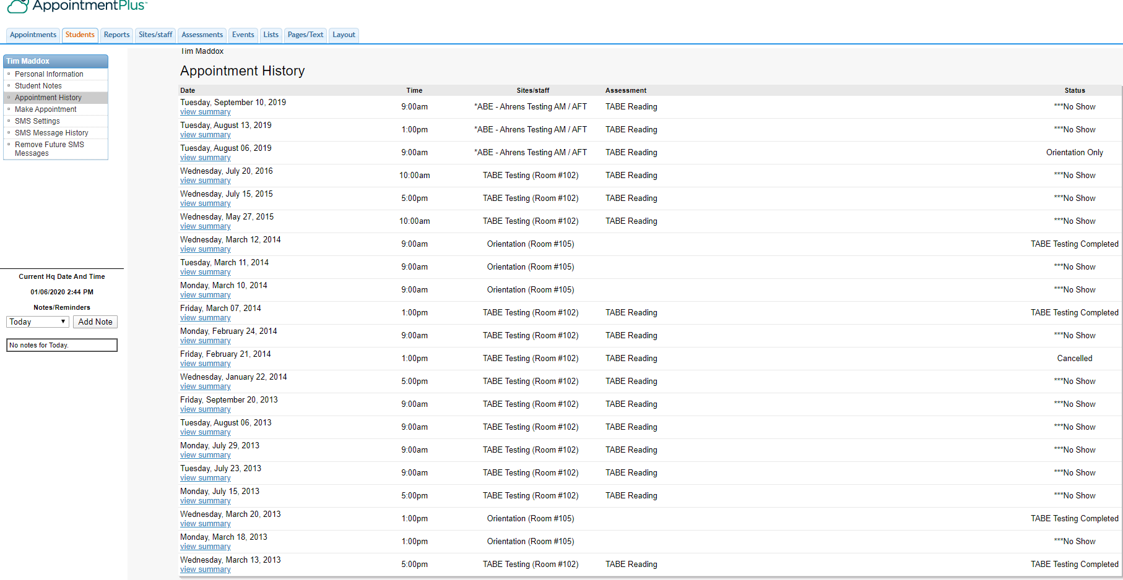

**Merging Students (Managed by the Administrator)**

The “**Merge Students”**link is used to merge students with duplicate profiles. You can search for students that have duplicate accounts by typing in their last name.

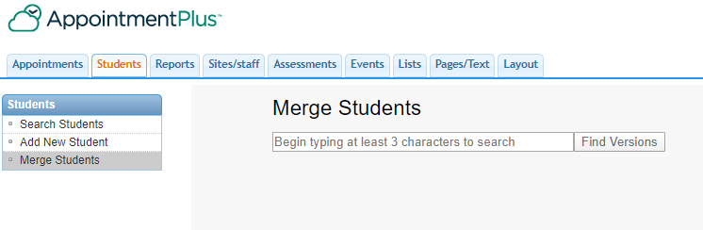

When you have selected a student, click the “Find Versions” button. A list of possible duplicate student profiles will be displayed. The accounts will be merged into one profile, without any information being lost.

*Merging student records cannot be undone. Please be sure you want to merge the profiles into a single record before completing the merge.

**Deleting Students**

To delete a student’s profile, use the search options to locate the appropriate student profile. The far-right column will have a delete option. Click on the delete link.

Make sure you want to delete this student from the system. When you delete a Student, it deletes their entire history.

**Changing Student Information**

Student information can be edited after searching for and clicking on the student’s name. This will show the student’s profile form. Changes can be made to any of the fields. When all changes have been entered, click “Update” to save them to the student database.

It is extremely important that the Student Information page be completed as follows:

1. All of the “red dot areas” need to be completed by the staff entering the student into AP+.

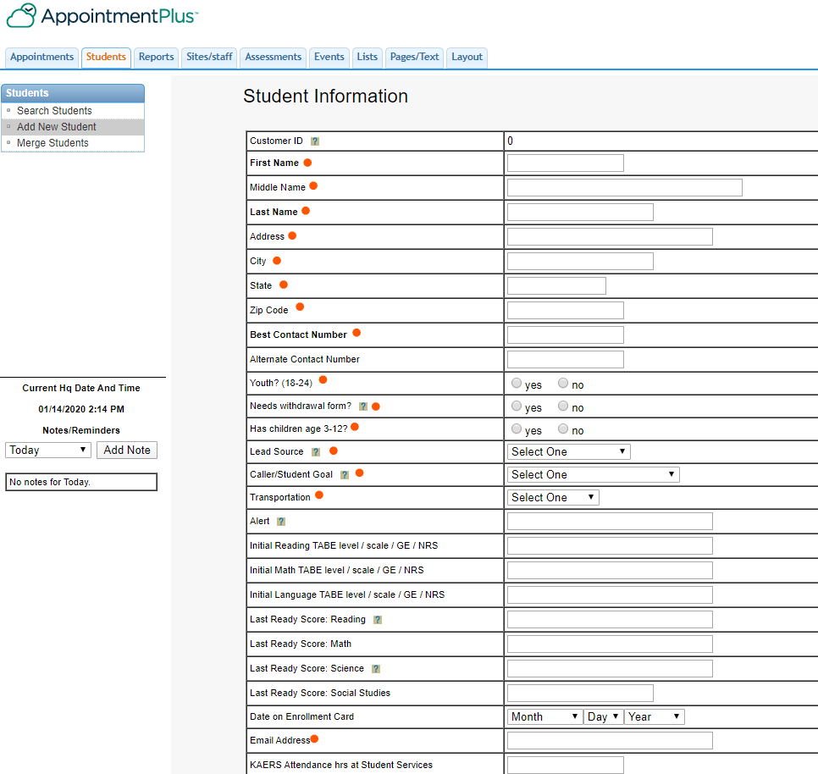

The “green dot areas” are to be completed by the test proctors.

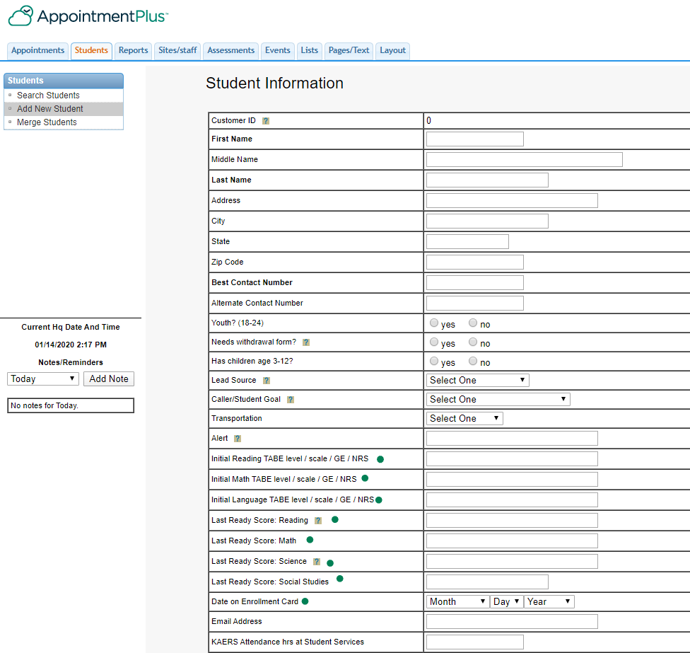

1. **Reports**

For each report, you will need to set the criteria you want for the report. Below is an example of a report for “No Show”.

Click the Report tab at the top of your screen. Then select “**Appointment Reports**”. For this report, the following criteria was entered:

Appointment Date Appointment Status (Click arrow

Assessment button; you will see a drop down

Student’s First and Last Name box, hit NONE and choose which

Best Contact Number Assessment you choose to run)

Start Time Student Notes

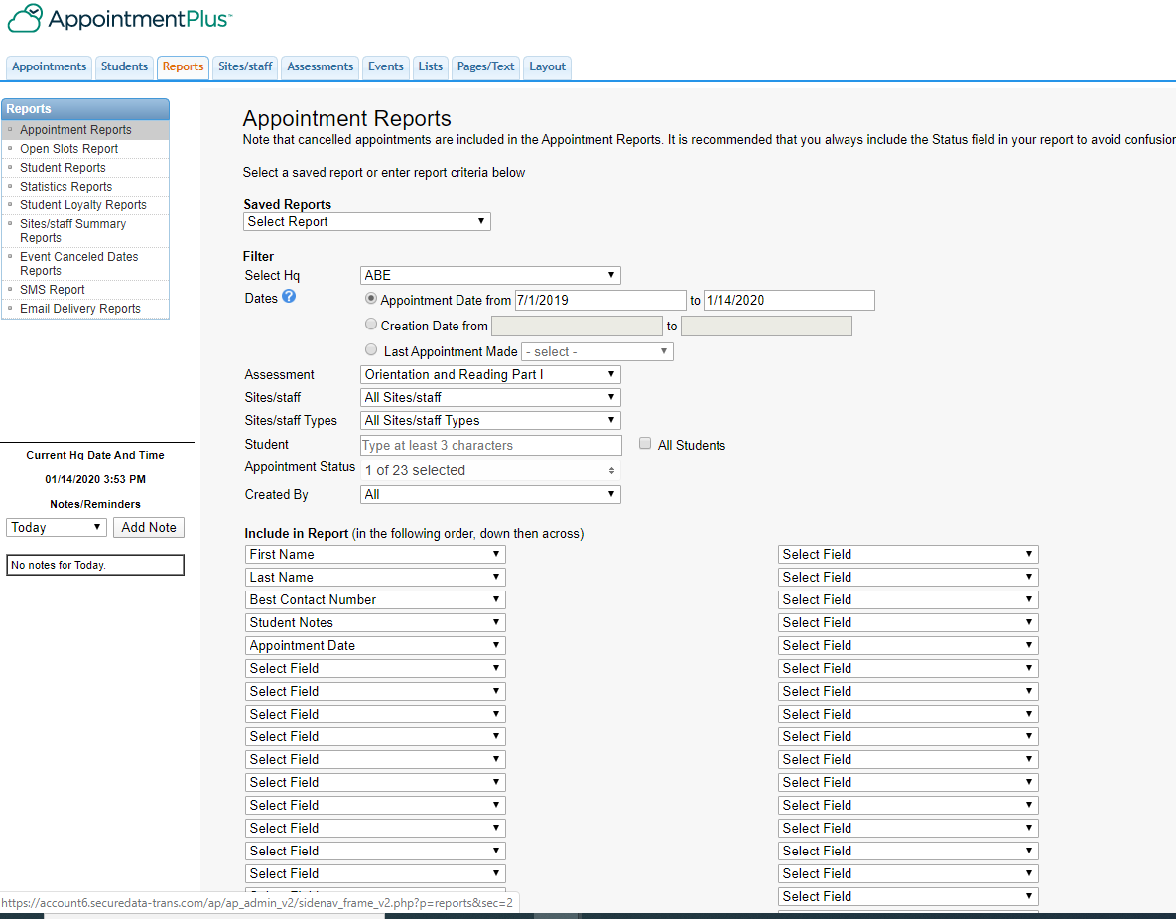

Click “**Run**” at the bottom of the page.

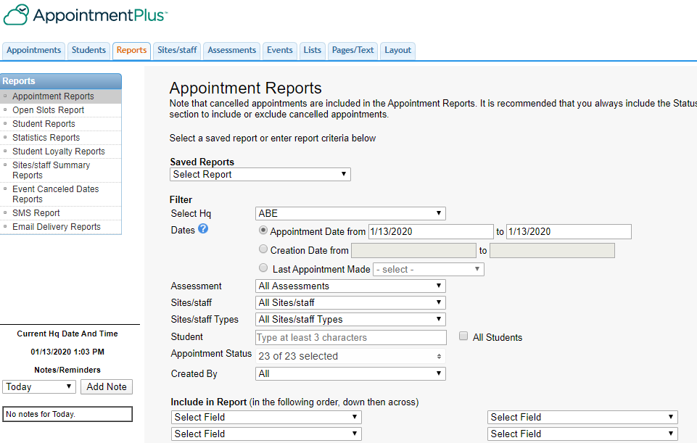

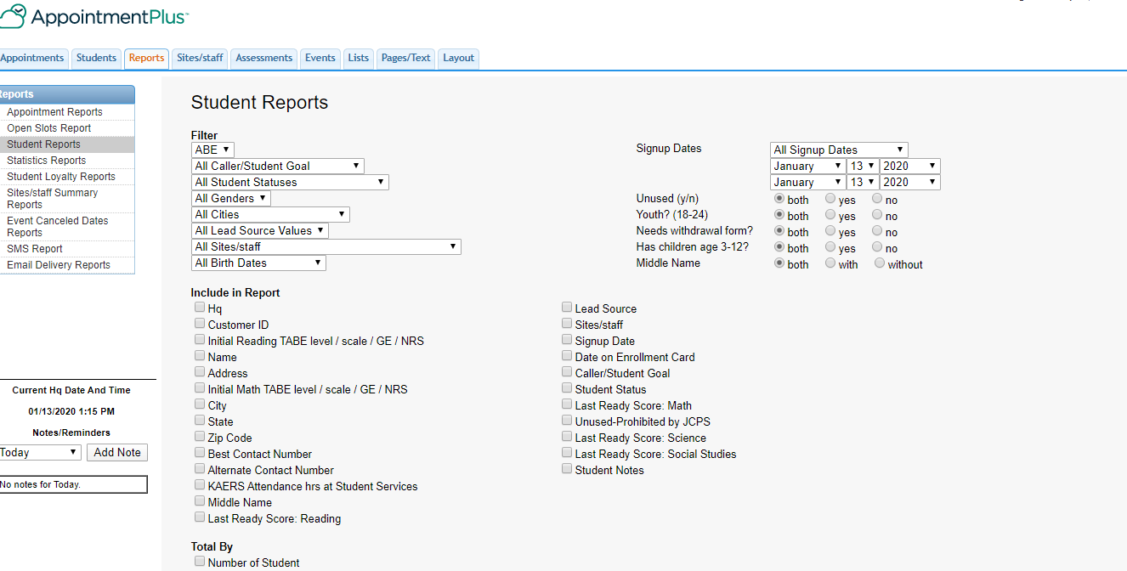

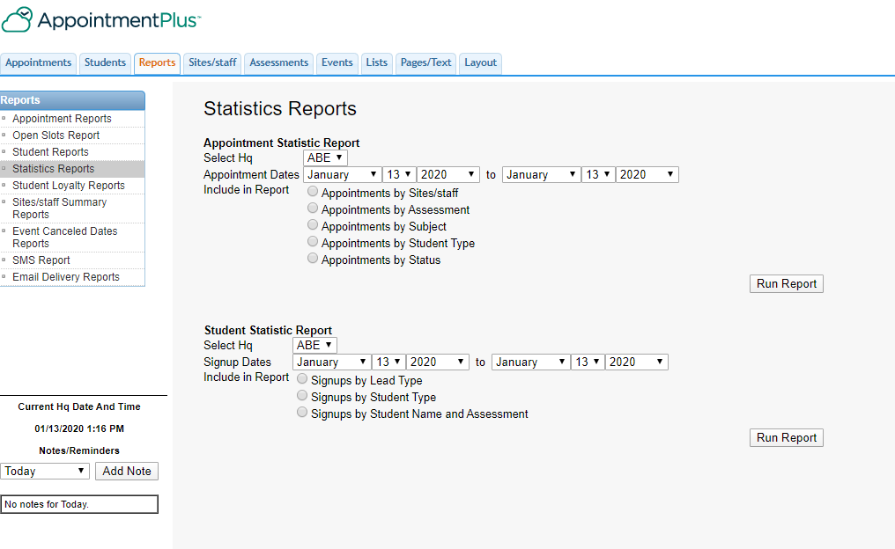

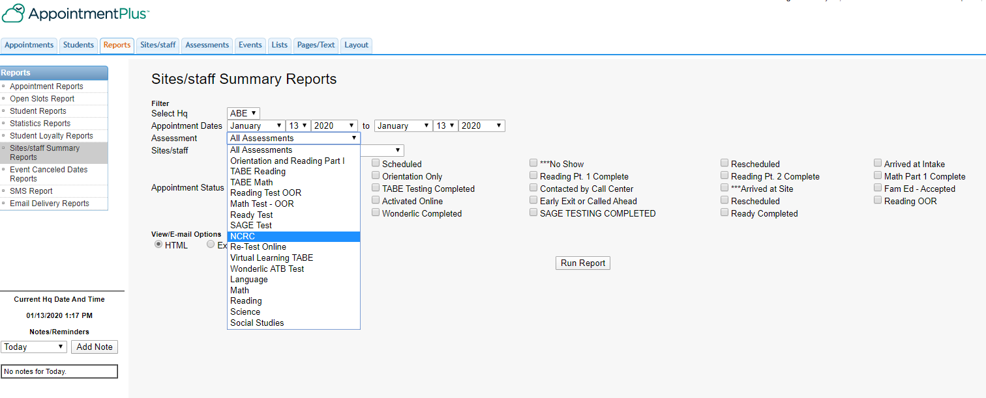

**Sample:**

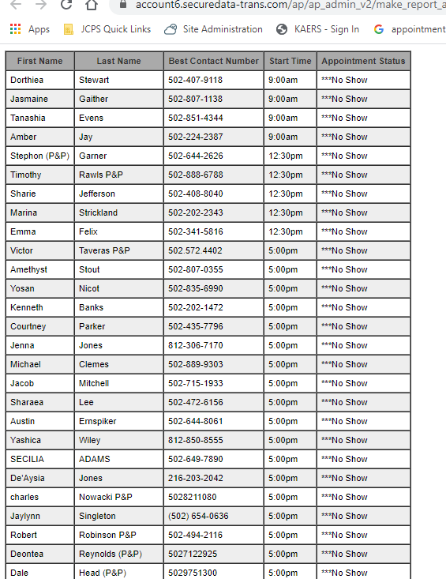

1. **Sites/staff**

A running record of all staff and sites is maintained here; information is edited only by the administrator.

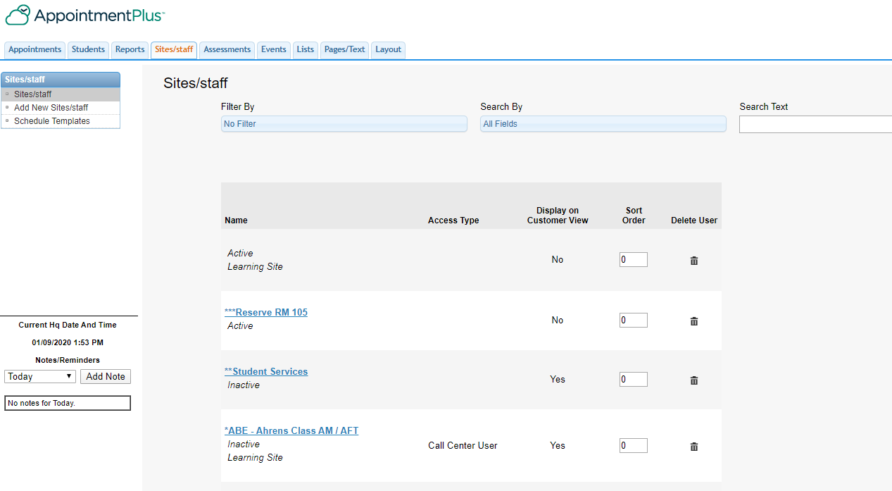

It is simple to add new staff or a site completing general information. Parts A & B.

Part A

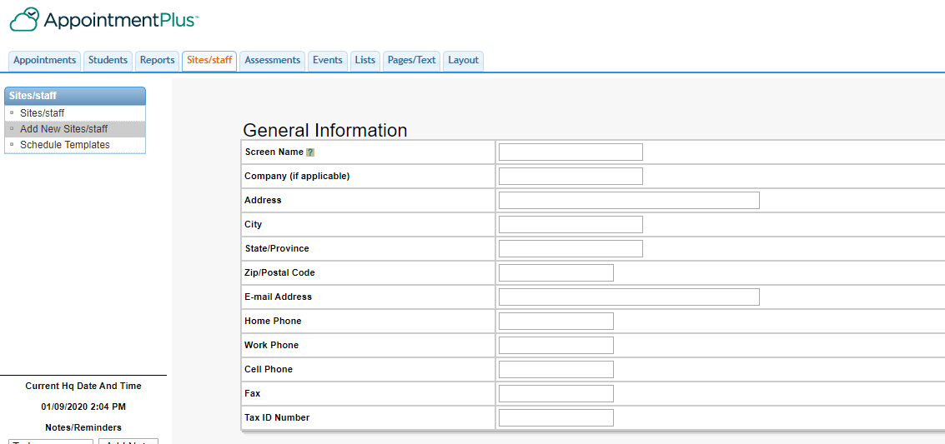

Part B

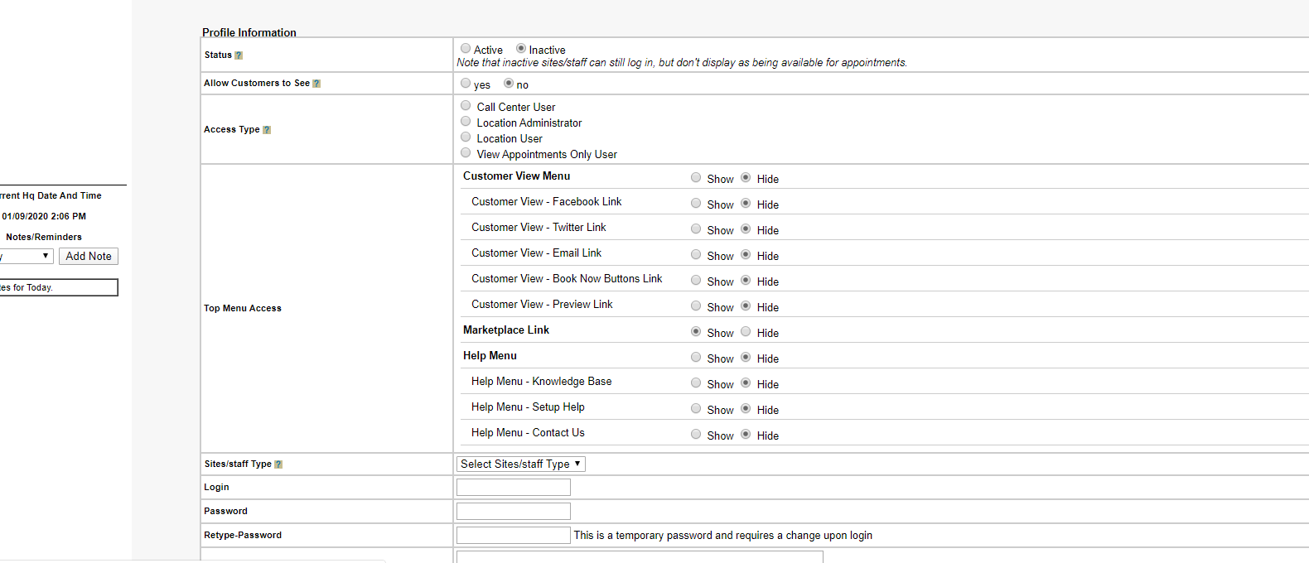

The majority of staff should be entered as a Call Center User. They do not have access to make changes. The administrator needs to be contacted to make changes, add staff and/or sites.

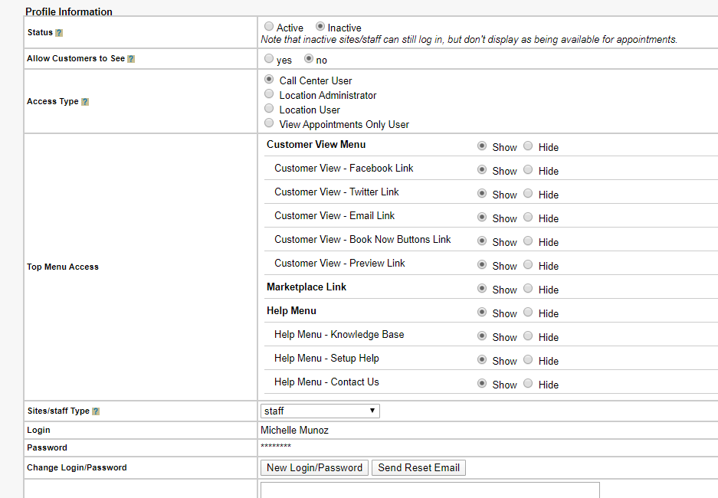

1. **Assessments (Managed by the Administrator)**

The assessments tab lists the assessment we currently provide.

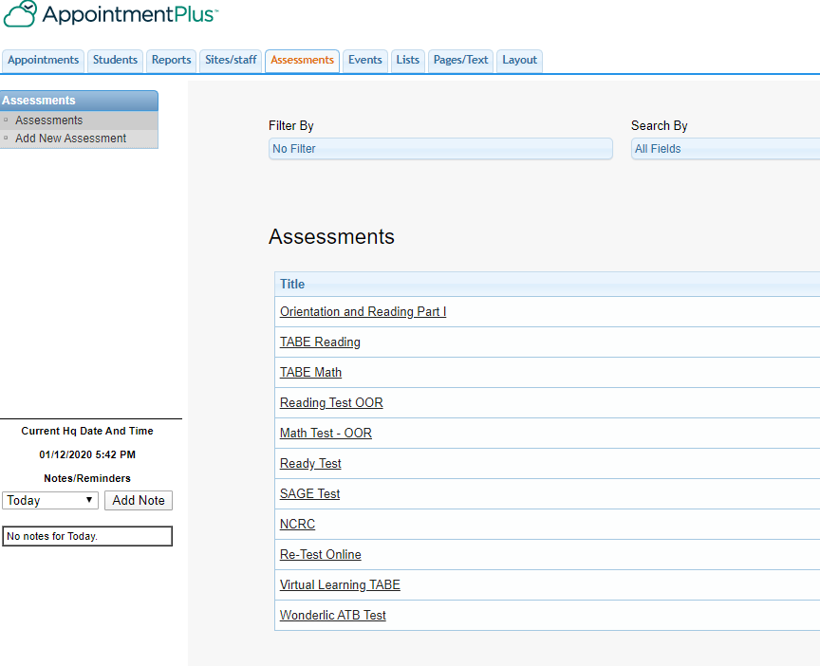

The details explain the assessment and outline the administration of the test.

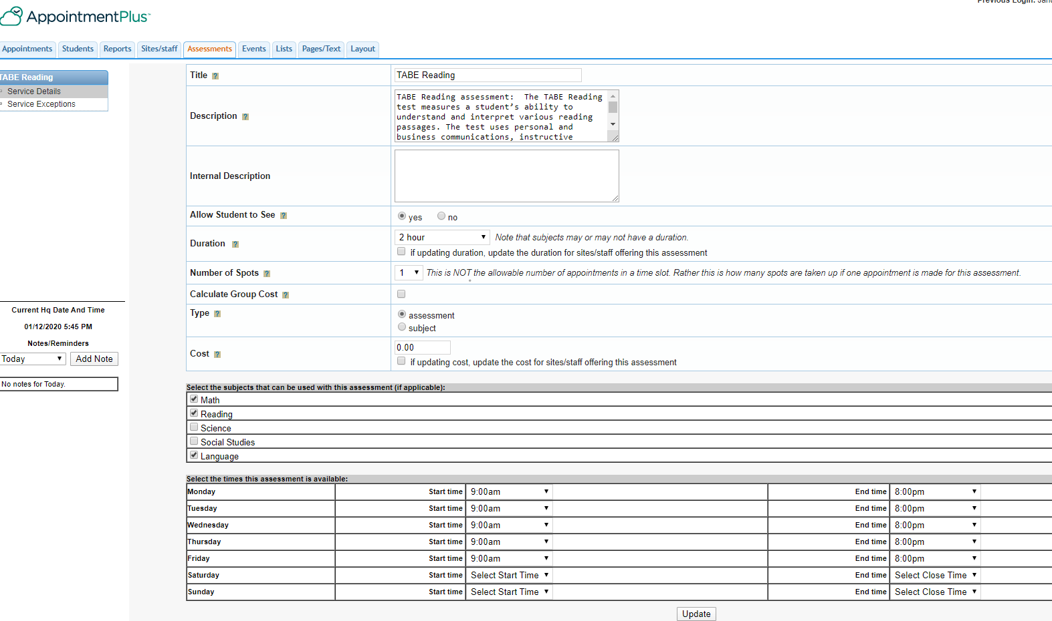

1. **Events (Managed by the Administrator)**

The Events tab is NOT utilized in the Call Center. It would be predominantly used by a company who hosts events on a regular basis. Just FYI, below are the basic templates.

1. The listing of current events.

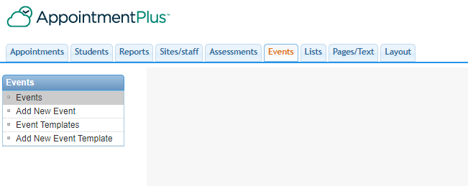

1. To add a new event:

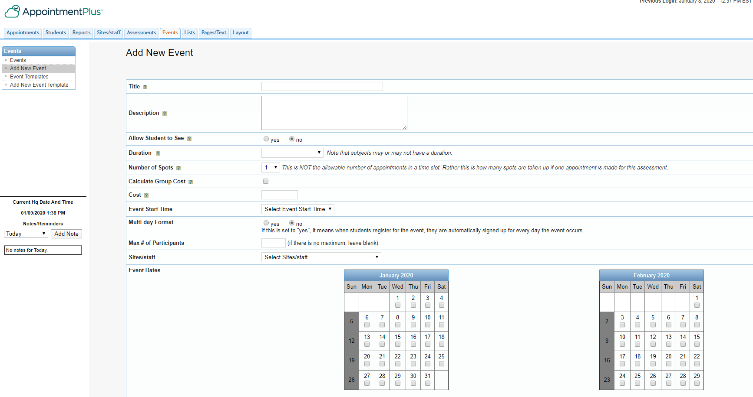

1. To add a new event template:

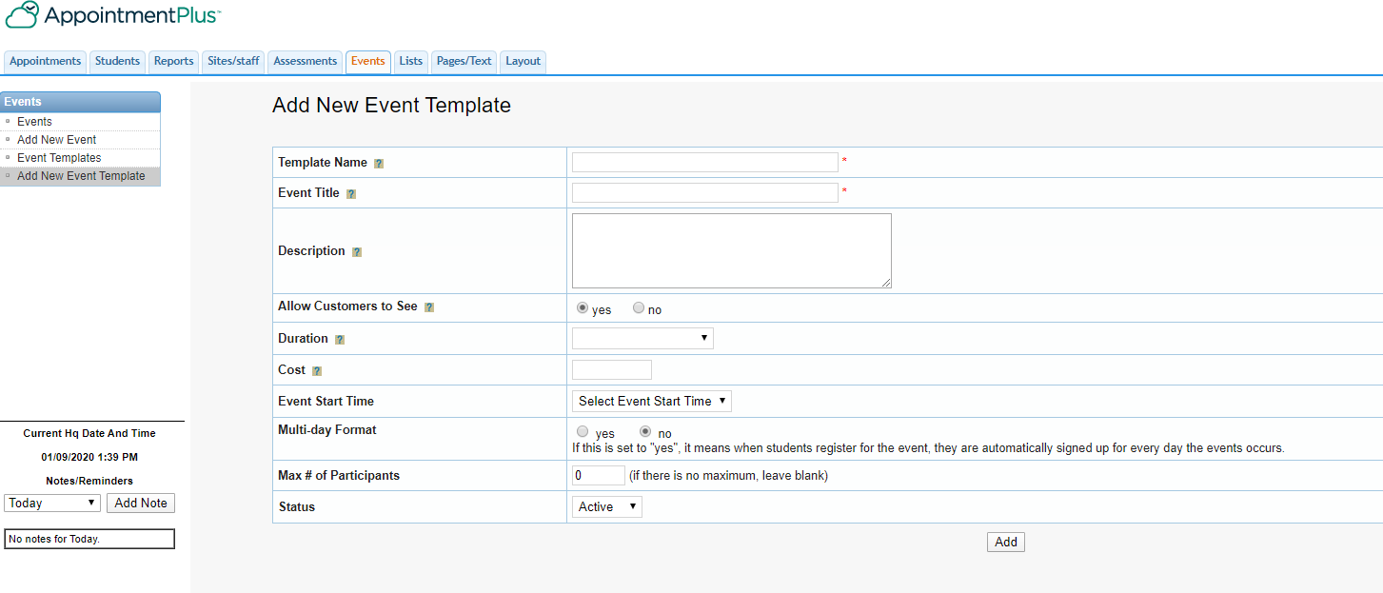

1. **Lists (Managed by the Administrator)**

The Lists section contains the details of our services. Major choices are shown below in short segments.

1. Lead Source Types

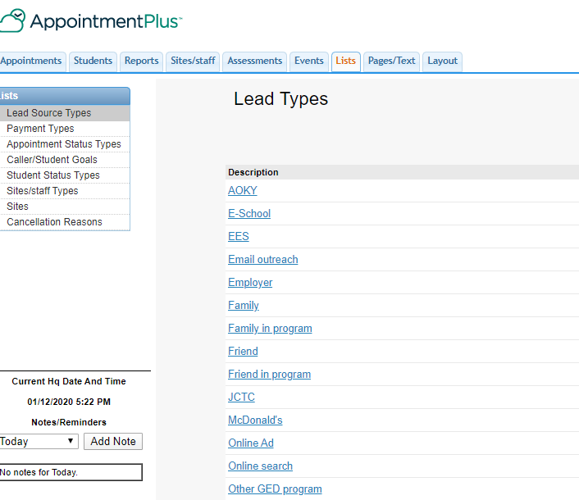

1. Payment Types

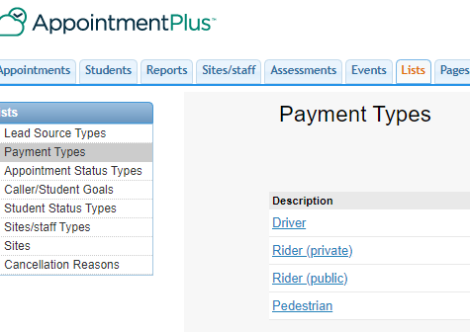

1. Appointment Status

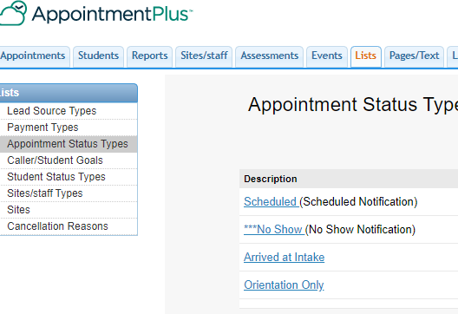

1. Student Goals

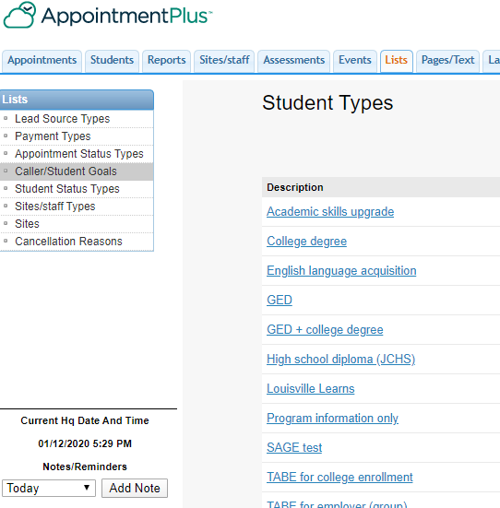

1. Student Status

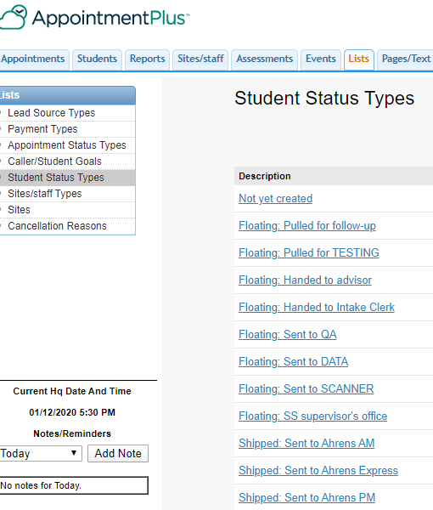

1. **Pages/text (Managed by the Administrator)**

Descriptions for text areas in AP+.

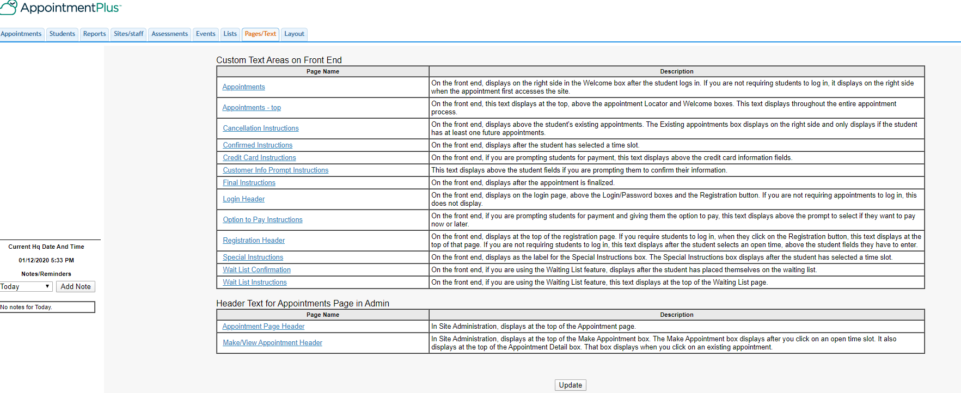

1. **Layout (Managed by the Administrator)**

Instructions for creating headings and color coding.

