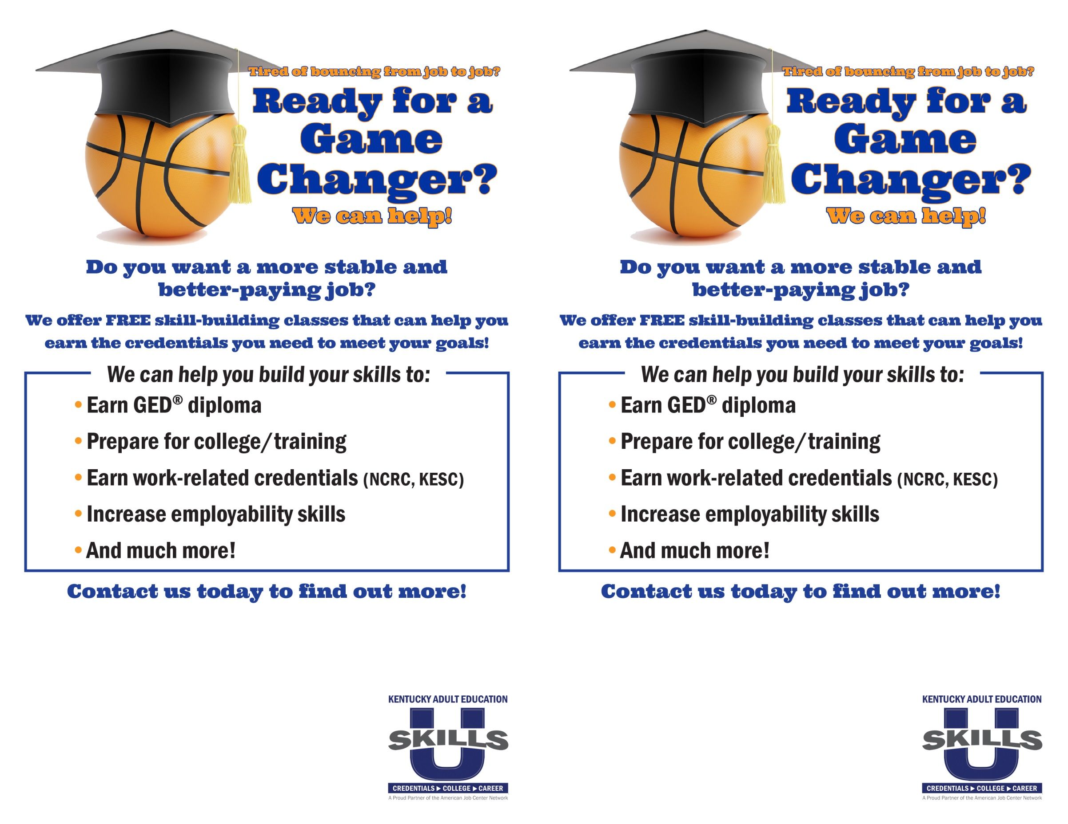

Your program’s name

Address line 1

Address line 2

Phone number

Your program’s name

Address line 1

Address line 2

Phone number

Program Name

Address

Phone Number

Program Name

Address

Phone Number

**Your program’s name**

Address line 1

Address line 2

**Phone number**

**Your program’s name**

Address line 1

Address line 2

**Phone number**

**Your program’s name**

Address line 1

Address line 2

**Phone number**

**Your program’s name**

Address line 1

Address line 2

**Phone number**

**Your program’s name**

Address line 1

Address line 2

**Phone number**