GED EXPRESS offers a quick path to the GED for those who do not need extensive instruction

Opportunity to work toward your GED while also earning
college credentials

College and Career Navigator
assists with college and career goals

Classes are offered during the
day and evening

Modular classes target specific subjects

Academic tutoring with a Success Coach, thanks to a grant from
United Way of Central Kentucky

Classes are offered in
Elizabethtown and Radcliff

On-line/Distance Learning
is available

Free GED Ready testing
saves you $24

STEEPLY DISCOUNTED
GED testing
thanks to the Educational Opportunity Center (EOC) and a grant from Dollar General

All services are FREE and convenient.
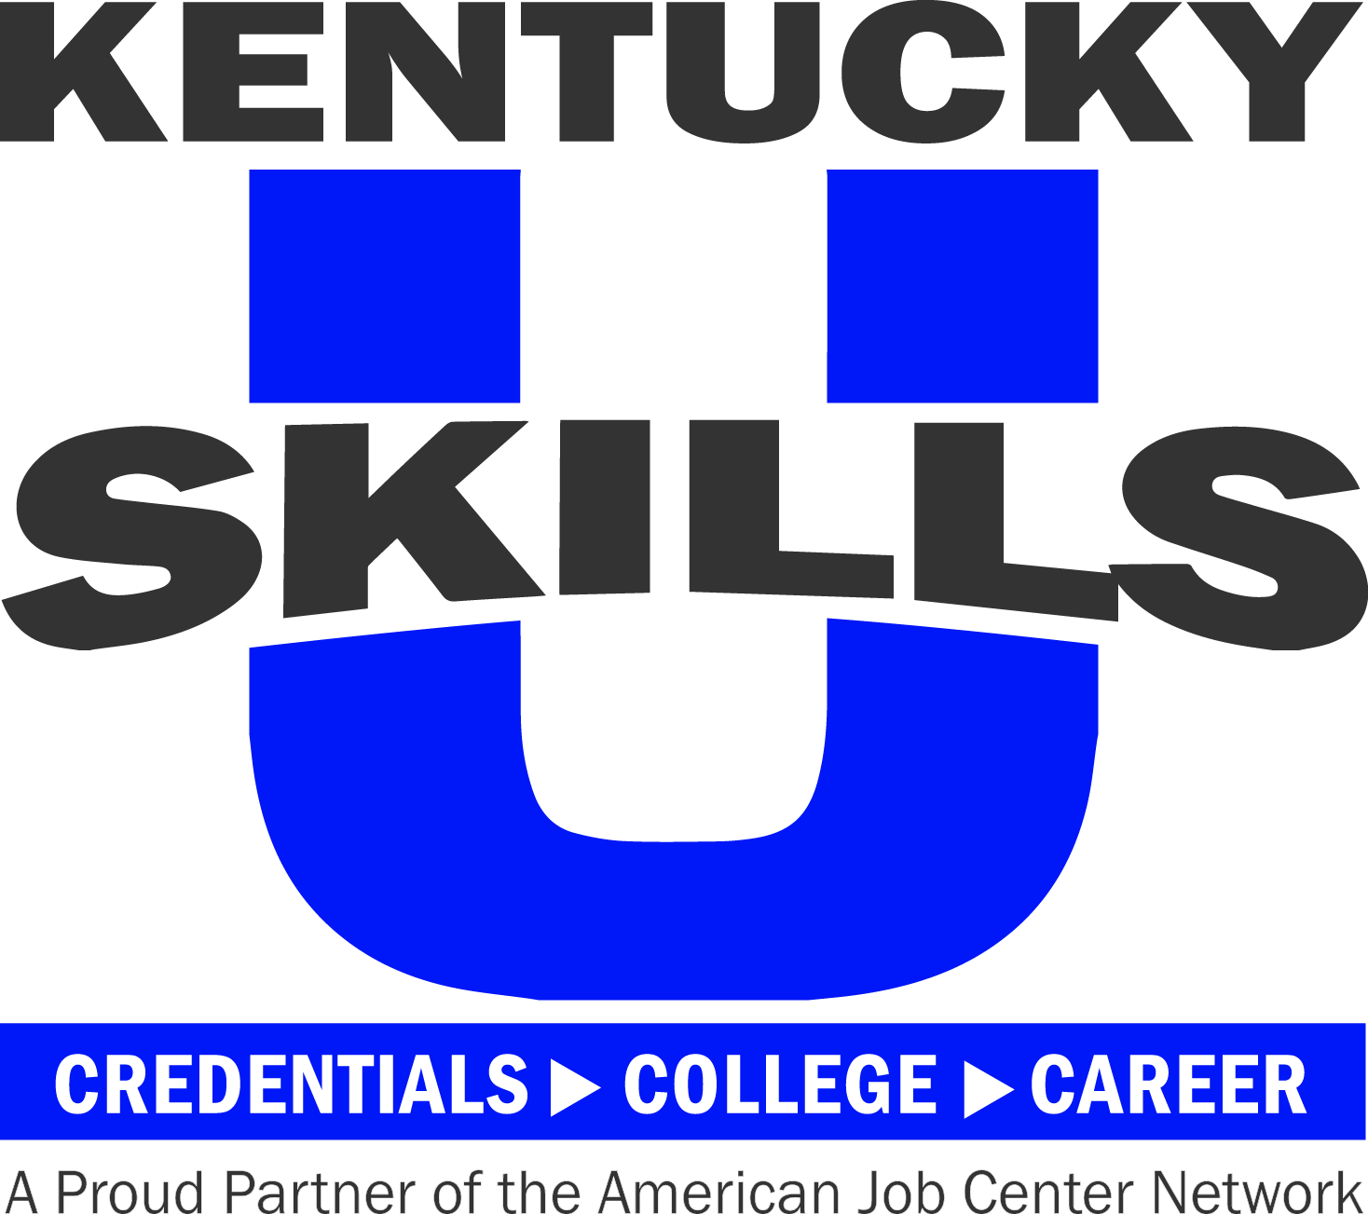
How can
Hardin County SKILLS U
help Kentuckians prosper?
Contextualized GED instruction and
GED Ready Assessment

College and Career Readiness preparation

National Career Readiness (NCRC) and Kentucky Career Readiness (KCRC) Certifications

Kentucky Essential Skills Certificate (KESC) Employment Soft Skills

Assistance improving basic skills: reading, math, and language

Instruction to improve speaking, reading, writing skills, and citizenship civics for English Language Learners
All class lessons are enhanced with use of technology and the Kentucky Adult Education Employability Standards

SNAP Able-Bodied Adults without Dependents (ABAWDs) and MEDICAID Able-Bodied Participant authorized agent for work requirements providing education and work ready training activities

To find out more about how we can help YOU, call (270) 769 8866

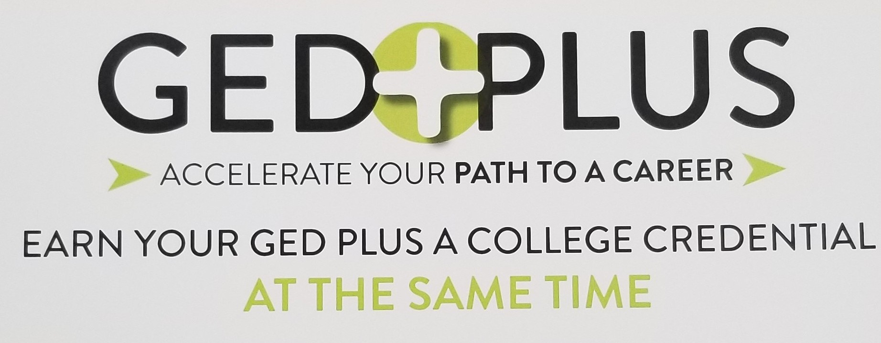

Hardin County SKILLS U is about
the future. For all Kentuckians to
prosper, every citizen must be
prepared to function well in the
workforce, the community,
and the home. The bottom line
is simple. If Kentuckians
have a good education:

• They can compete for good jobs.

• They can support their families.

• Their children are more likely to
succeed in school and beyond.

• The Commonwealth can make a
compelling case for companies
opening or expanding their
businesses in Kentucky.

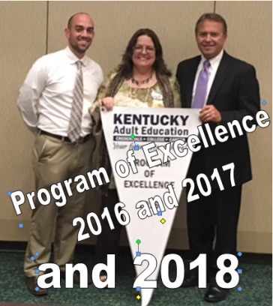

MEET
JEREMY

Hardin County
SKILLS U

MISSION: The mission of Hardin County Skills U is to provide instructional programs, support, and encouragement to empower all individuals in meeting their educational, personal, career, and family goals.

VISION: Our vision is to meet the changing needs of the community by continuously developing, monitoring, and improving our programs and services.

VALUES: We value the uniqueness of all individuals and the contributions they make in our community.

HARDIN COUNTY

Serving GED – Seekers
and
High School Graduates
Needing Additional Academic Services to Achieve Higher Education Goals

located at
Elizabethtown Community and Technical College
E C T C
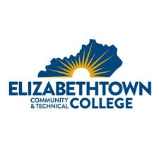
OTB Room 310
600 College Street Rd
Elizabethtown, KY 42701

(270) 769 8866 or
(270) 769 8875

ASK US ABOUT

Hardin County SKILLS U

Director: Diane Kelley
diane.kelley@hardin.kyschools.us

(270) 706 8017
(270) 769 8866
Cell (270) 304 4893

Main Office

Elizabethtown Community and Technical College
(ECTC)
OTB Room 310
Elizabethtown, KY 42701
(270)769-8866 or (270)769-8875
website www.hardin.kyschools.us/adulted/
https://www.facebook.com/hardincountyadulteducation

Classes in Elizabethtown (two locations)
and Radcliff

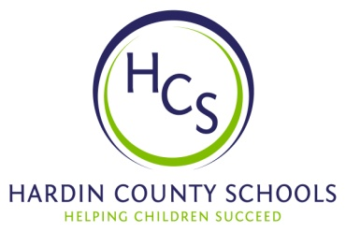
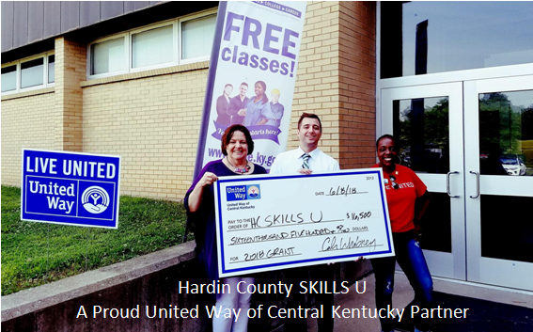
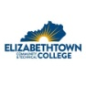

Jeremy is a steadfast and dedicated learner who took advantage of our EMPOWER Success Coach services (funded by the United Way of Central Kentucky). The one-on-one tutoring with wrap-around services coupled with SKILLS U classes helped Jeremy overcome obstacles and
EARN HIS GED!
He plans to attend ECTC in the fall.

